Empirical Methods

Introduction

Econometrics
= empirical arm of economics combination of statistics and economics

Types of Analyses
Three different types of analyses:
- Descriptive Analysis, e.g. How do prices for similar goods vary across countries?
- Causal Analysis, e.g. What is the effect of a dual-education system on youth employment?
- Prediction/Forecasting, e.g. What will the interest rate/stock price/… be next week/month/…?

Correlation vs. Causation
Statistics tells if two variables are correlated, economic models and assumptions help to infer causation.
e.g. Correlation between Americanization of names and economic success, but does changing the name cause higher earnings??

Causation
For $y=β_{0}+β_{1}x_{1}+…+β_{k}x_{k}+ϵ_{i}$, the key assumption is $E\left(ε_{i}|x_{i}\right)=0$, implying $Cov\left(ε_{i}, x_{i}\right)=0$.

Economic Research

Experiment
- Choose a group of identical people from the population of interest
- Randomly assign them to treatment of control group
- Compare outcomes between groups
Problem: often unethical, costly, … impossible
Natural Experiment
= situation in the real world, that replicated conditions of a controlled experiment

Classic Linear Regression Model

Econometrics as Regression
= statistical technique that attempts to “explain” movements in one variable, the dependent variable $y_{i}$, based on movements in a set of other variables, the explanatory variables $x_{i1}, x_{i2},…,x_{iK}$

Use of Regression
- Descriptive Analysis ”sophisticated data summary”
- Causal Analysis measure the causal effect of a particular $x_{ik}$ on $y_{i}$
- Prediction try to predict $y_{i}$ based on a set of $x_{i}$

relies on results from probability and statistics

Probabilistic and Statistical Foundations

Probabilistic Foundations

Random Variables
= variable whose possible values are numerical outcomes of a random phenomena
defined by: the values it takes
a probability distribution over these values
dependent variable ($y_{i}$) and explanatory variables ($x_{i}$) are random variables

Univariate Random Variable
= random variable, with probability distribution that concerns only one random variable
can be discrete (= taking a limited number of distinct values)
or continuous (= taking an infinite number of values over a continuum)

Probability Distribution
- Probability distribution of a discrete variable: $p\left(y_{i}=y_{r}\right)=p_{r}$
e.g. $p\left(y_{i}=5.5\right)=0.124=12.4\%$
- Probability distribution of a continuous variable: $P\left(a≤x_{i}≤b\right)=\int_{a}^{b}{f\left(x_{i}\right)dx_{i}}$
- Probability density function (PDF): function whose value at any point in the set of values the random variable can take provides relative likelihood that the value of the random variable equals that point

Mean, Variance and Standard Deviation

Mean (E(x_{i}), Ex or μx)
= expected value (measures “center” of the distribution):
- Discrete univariate random variable: $E\left(x\right)=\sum_{s=1}^{R}{p_{s}x_{s}}$
- Continuous univariate random variable: $Ex=\int_{a}^{b}{xf\left(x\right)}dx$

Variance (V(x_{i}), Vx or σ²_{x}) and Standard Deviation (SD(x_{i}) or σ_{x})
measures “spread” of the distribution around its mean
Variance: $V\left(x_{i}\right)=E\left[{\left(x_{i}-Ex\right)}^{2}\right]=E\left(x_{i}^{2}\right)-{\left(Ex\right)}^{2}$
Standard deviation: $SD\left(x_{i}\right)=\sqrt{V(x_{i})}$

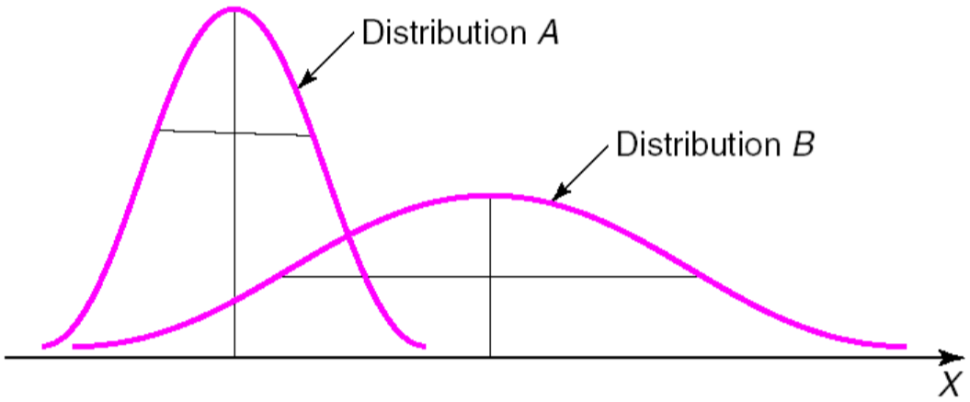
Example
Compare distributions A and B:
- A is “centered” to the left of B μ_{A}< μ_{B}
- A is less “spread out” σ²_{A}< σ²_{B}

Properties of Expected Values, Variance and Standard Deviation
$y_{i}=a+bx_{i}$
$E\left(y_{i}\right)=E\left(a+{bx}_{i} \right)=E\left(a\right)+E({bx}_{i})=a+bE\left(x_{i}\right)$
$V\left(y_{i}\right)=V\left(a+bx_{i}\right)=V\left(a\right)+V\left(bx_{i}\right)=b^{2}⋅V(x_{i})$ $SD\left(y_{i}\right)=\sqrt{b^{2}V(x_{i})}=\sqrt{b^{2}}\sqrt{V(x_{i})}=b⋅SD(x_{i})$

Common Univariate Random Variables

Normal Distribution
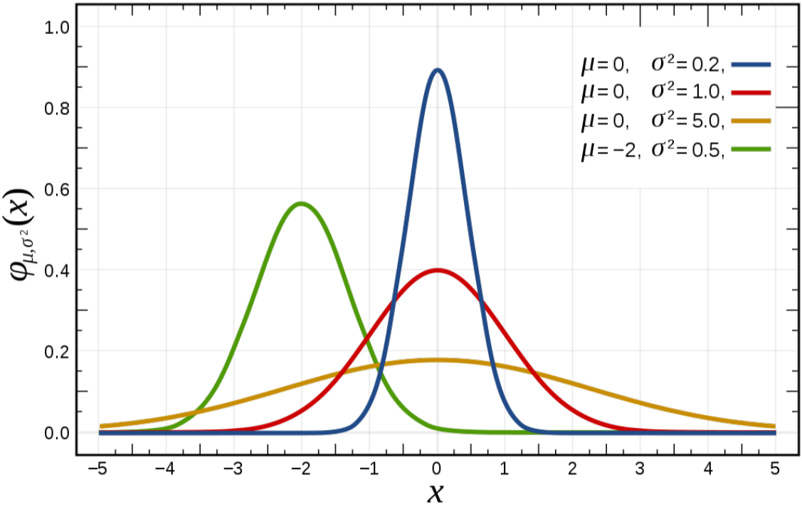
Random variable $x_{i}$ is normally distributed: $x_{i}∼N(μ_{x}, σ_{x}^{2})$
mean:$μ_{x}$, variance: $σ_{x}^{2}$
PDF: $f\left(x_{i}\right)=\frac{1}{\sqrt{2πσ_{x}}}e^{-\frac{{\left(x_{i}-μ_{x}\right)}^{2}}{2σ_{x}^{2}}}$ ”bell-shaped”
67% within 1sd of mean, 95% within 2sd of mean

Linear transformation
$x_{i}∼N(μ_{x}, σ_{x}^{2})$ and $y_{i}=a+bx_{i}$ $y_{i}∼N(a+bμ_{x}, b^{2}σ_{x}^{2})$ this is used for standardization

Standard Normal Distribution
Standardize normal distribution $x_{i}∼N(μ_{x}, σ_{x}^{2})$ using a linear transformation: $x_{i}=μ_{x}+σ_{x}z$:
Random variable $x_{i}$ is standard normal distributed: $x_{i}∼N(0, 1)$ (or $z=\frac{x-μ_{x}}{σ_{x}}∼N(0, 1)$)
mean: 0, variance: 1
PDF: $ϕ\left(z\right)=\frac{1}{\sqrt{2π}}e^{-\frac{y^{2}}{2}}$

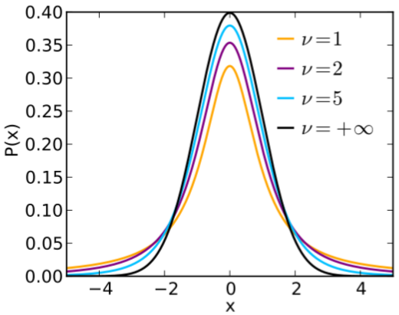
(Student’s) t-distribution
Random variable $x_{i}$ is t-distributed with $v=N-1$ degrees of freedom: $x_{i}∼t_{k}$
incorporates additional uncertainty from estimated $σ_{x}^{2}$
similar to normal distribution, but “fatter tails”

$χ$² Distribution
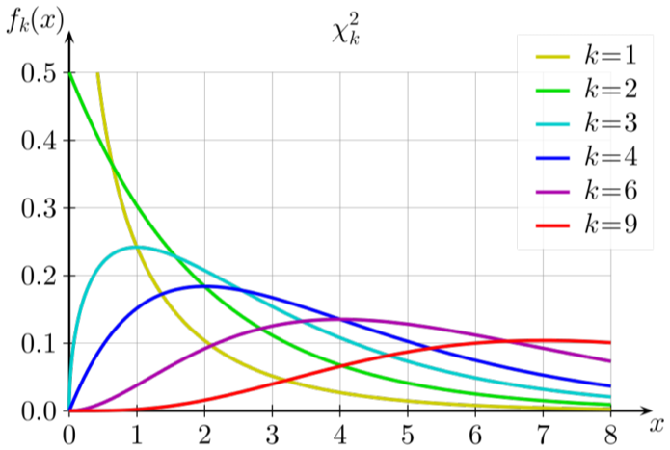
Random variable $x_{i}$ has $χ^{2}$ distribution with $k$ degrees of freedom: $x_{i}∼x_{k}^{2}$
distribution of sum of the squares of k independent standard normal random variables
($k$ = number of restrictions in hypothesis, e.g. H₀: $β_{1}=0$ and $β_{2}=0$ $k=2$)

(“Snedecor’s”) F-distribution
Random variable $x_{i}$ is F-distributed with $v_{1}$ numerator and $v_{2}$ denominator degrees of freedom:
$x_{i}∼F(v_{1},v_{2})$ where $v_{1}=q$, $v_{2}=N-K$ ($q=\#hypotheses, N=\#observations, K=\#β's (incl. β_{0})$)
Which Distribution for which Hypothesis Test?
Single hypothesis: normal distribution (if $σ_{2}$ known) or t-distribution (if $σ_{2}$ estimated)
Multiple hypotheses: $χ^{2}$ distribution (if $σ_{2}$ known) or F distribution (if $σ_{2}$ estimated)

Multivariate Random Variable
= random variable with probability distribution that concerns $K$ random variables $x_{i1}, x_{i2},…,x_{iK}$
defined by: the values each random variable can take
a “joint” probability distribution for all the random variables

Probability Distribution
defined by the probability of each possible combination of values of the $K$ random variables
- Probability distribution of a multivariate discrete RV: $P\left(x_{i}=x_{s}, y_{i}=y_{r}, …\right)=p_{sr…}$
- Probability distribution of a multivariate continuous RV: $P\left(a≤x_{i}≤b, c≤y_{i}≤d\right)=\int_{c}^{d}{\int_{a}^{b}{f\left(x_{i}\right)dx_{i}}dy_{i}}$
joint probability density function (joint PDF)

Concepts and Properties

Marginal Distributions
= distribution of one component of a joint probability distribution
add up over all of the other components:
- Multivariate discrete RV: $P\left(y_{i}=y_{r}\right)=\sum_{s…}{P(x_{i}=x_{s}, y_{i}=y_{r},…)}=\sum_{s…}{p_{sr…}}$
Example: $P\left(y_{i}=5.5\right)=\sum_{s}{P\left(x_{i}=x_{s}, y_{i}=5.5\right)}=P\left(x_{i}=male, y_{i}=5.5\right)+P\left(x_{i}=female, y_{i}=5.5\right)$
- Multivariate continuous RV: $f\left(x_{i}\right)=\int_{y_{i,min}}^{y_{i,max}}{f\left(x_{i}, y_{i}\right)dy_{i}}$

Conditional Distributions
= probability that one RV $y_{i}$ takes a certain value given the others have a particular value $x_{i}=x_{s}$
- Multivariate discrete RV: $P\left(y_{i} | x_{i}=x_{s}\right)=\frac{P(x_{i}=x_{s}, y_{i}=y_{s})}{P(x_{i}=x_{s})}$ ($\left(y_{i} | x_{i}=x_{s}\right)$: univariate distribution!)
- Multivariate continuous RV:

Mean and Variance
can be calculated for: component of set of multivariate RV (e.g. $E(x_{i})$) use marginal distribution
conditional variables (e.g. $E(y_{i}|x_{i})$)

Covariance
= measure of the degree of (linear) association between two random variables:
$Cov\left(x_{i}, y_{i}\right)=σ_{xy}=E\left[(x_{i}-Ex)(y_{i}-Ey)\right]=E\left(x_{i}y_{i}\right)-ExEy$
”units issue”: if $x_{i}$ is measured in hours, $y_{i}$ in grade points, then $σ_{xy}$ is in “hours-grade points”

Correlation
$ρ_{xy}=\frac{σ_{xy}}{σ_{x}σ_{y}}=\frac{Cov(x_{i}, y_{i})}{SD\left(x_{i}\right)SD(y_{i})}$
unitless no “unit issue”

Independent Random Variables
= random variables with joint distribution function that equals the product of the respective marginal distribution: $P\left(x_{i}=x_{s}, y_{i}=y_{r}\right)=P\left(x_{i}=x_{s}\right)P(y_{i}=y_{r})$

Combinations of RV’s
Mean: $E\left(x_{i}+y_{i}\right)=E\left(x_{i}\right)+E\left(y_{i}\right)$
Variance: $V\left(x_{i}+y_{i}\right)=V\left(x_{i}\right)+V\left(y_{i}\right)+2Cov(x_{i}, y_{i})$ and $V\left(x_{i}-y_{i}\right)=V\left(x_{i}\right)+V\left(y_{i}\right)-2Cov(x_{i}, y_{i})$

Statistical Foundations

Regression as Conditional Mean Estimation
$E(y_{i}|x_{i})$ is not random, because $E\left(y_{i}\right)$ is not random and particular value of $x_{i}$ is not random
we can write: $E\left(y_{i} | x_{i}\right)=f(x_{i})$
regression decomposes random variable $y_{i}$ into its conditional mean (explained by function) given $x_{i}$ and an error term $ϵ_{i}$ (not explained by function): Population regression function: $y_{i}=E\left(y_{i} | x_{i}\right)+ϵ_{i}$
[Slides 39-45]

Populations vs Samples

Population
= set of similar items or events which is of interest for some research question or experiment
features (e.g. mean, variance…) of population are fixed (=non-random), but unknown

Sample
= subset of the population selected for analysis (to learn something about the population)
features (e.g. mean, variance…) of sample are random, but known

Simple Random Sample
= sample where 1. each element of population has equal change of being chosen
2. selection of one element has no effect on probability of other element being selected
set of random variables that is “independent and identically distributed (i.i.d.)”

Common Population Objects and its Sample “Equivalents” (used to estimate)
 | Population | Sample
Mean | $E(x_{i})$ or $μ_{x}$ | $\overline{x}=\frac{1}{N}\sum_{i=1}^{N}{x_{i}}$
Variance | $V\left(y_{i}\right)=σ_{y}^{2}=E\left[{\left(y_{i}-μ_{y}\right)}^{2}\right]$ | $s_{x}^{2}=\frac{1}{N-1}\sum_{i=1}^{N}{{\left(x_{i}-\overline{x}\right)}^{2}}$
Covariance | $$Cov\left(x_{i}, y_{i}\right)=σ_{xy}$$  $=E\left[(x_{i}-μ_{x})(y_{i}-μ_{y})\right]$ | $s_{xy}=\frac{1}{N-1}\sum_{i=1}^{N}{\left(x_{i}-\overline{x}\right)\left(y_{i}-\overline{y}\right)}$
Correlation | $$ρ_{xy}=\frac{σ_{xy}}{σ_{x}σ_{y}}$$ | $$r_{xy}=\frac{s_{xy}}{s_{x}s_{y}}$$

Sample Mean
- Mean of the sample mean:
$E\left(\overline{x}\right)=E\left(\frac{1}{N}\sum_{i=1}^{N}{x_{i}}\right)=\frac{1}{N}E\left(\sum_{i=1}^{N}{x_{i}}\right)=\frac{1}{N}\sum_{i=1}^{N}{E(x_{i})}=\frac{1}{N}\sum_{i=1}^{N}{μ_{x}}=\frac{1}{N}Nμ_{x}=μ_{x}$
$E\left(\overline{x}\right)=μ_{x}$, i.e. the expected value of the sample mean equals the population mean
- Variance of the sample mean:
$V\left(\overline{x}\right)=V\left[\frac{1}{N}\sum_{i=1}^{N}{x_{i}}\right]=\frac{1}{N^{2}}V\left[\sum_{i=1}^{N}{x_{i}}\right]$ |$V\left(x_{1},x_{2}\right)=V\left(x_{1}\right)+V\left(x_{2}\right)+2Cov(x_{1},x_{2})$
but $x_{i}$ are independent $Cov\left(\right)=0$
$=\frac{1}{N^{2}}\sum_{i=1}^{N}{{V(x}_{i})}=\frac{1}{N^{2}}\sum{σ_{x}^{2}}=\frac{1}{N^{2}}Nσ_{x}^{2}=\frac{N}{N^{2}}σ_{x}^{2}=\frac{1}{N}σ_{x}^{2}=\frac{σ_{x}^{2}}{N}$
$V\left(\overline{x}\right)=\frac{σ_{x}^{2}}{N}$, i.e. the variance of the sample mean decreases with N (”Law of Large Numbers”)

Population and Sample Regression Function

Population Regression Function
General population regression function: $y_{i}=E\left(y_{i} | x_{i}\right)+ϵ_{i}$
Linear population regression function: $y_{i}=β_{1}+β_{2}x_{i2}+…+β_{K}x_{iK}+ϵ_{i}$
$=x_{i}^{'}β+ϵ_{i}$
Error Term (real value)
= difference between true and observed value:
$ϵ_{i}=y_{i}-E\left(y_{i}|x_{i}\right)$
y_{i}
x_{i}
E(y_{i}|x_{i})
z
z
z
z
z
z
E(y_{i}|x_{i}=1)
z
y_{i}
ϵ_{i}
1
2
3
4
5
6

Sample Regression Function
Residual (estimated!)
= difference between true and estimated value:
$e_{i}=y_{i}-{\hat{y}}_{i}=y_{i}-x_{i}^{'}\hat{β}$
$y_{i}=x_{i}^{'}\hat{β}+e_{i}$

Alternative Approaches to Regression

Regressions

Ordinary Least Squares (OLS)
Minimize the sum of squared residuals: $\min_{\hat{β}}{\sum_{i=1}^{N}{{\left(y_{i}-x_{i}^{'}\hat{β}\right)}^{2}}}$

(Generalized) Method of Moments (GMM)
Equate the moments of a statistical model with the actual moments in the sample
Moments of Random Variables
r^{th} moment of $x_{i}$: $E(x_{i}^{r})$ 1st moment is mean
r^{th} central moment of $x_{i}$: $E[{\left(x_{i}-Ex\right)}^{r}]$ 2nd central moment is variance

Maximum Likelihood Estimation (MLE)
- Assume: data generated by particular family of distributions with unknown parameters $β$
- Choose an estimator $\hat{β}$, to maximise the likelihood of seeing the actual sample that we see

How to Choose Between Estimators?
Consider different properties of the estimators:
- Unbiasedness: $\hat{β}$ is unbiased if $E\left(\hat{β}\right)=β$
- Efficiency (or Minimum Variance): ${\hat{β}}_{1}$ is more efficient than ${\hat{β}}_{2}$ if $V\left({\hat{β}}_{1}\right)<V\left({\hat{β}}_{2}\right)$
(or in large samples: consistency and asymptotic normality)
we need to know the actual distribution

The Classical Linear Regression Model and OLS

The Classical Linear Regression Model

Simple Classical Linear Regression Model (One Regressor)
$y_{i}=β_{1}+β_{2}x_{i}+ϵ_{i}$

Multiple Classical Linear Regression Model (Multiple Regressors)
$y_{i}=β_{1}+β_{2}x_{i2}+…+β_{K}x_{iK}+ϵ_{i}$

CLRM in Summation Notation
$y_{i}=\sum_{k=1}^{K}{β_{k}x_{ik}}+ϵ_{i}$
$=x_{i}^{'}β+ϵ_{i}$, where $x_{i}=\left[\begin{matrix}\begin{matrix}x_{i1} \\ x_{i2}\end{matrix} \\ ⋮ \\ x_{iK}\end{matrix}\right]$ and $β=\left[\begin{matrix}\begin{matrix}β_{1} \\ β_{2}\end{matrix} \\ ⋮ \\ β_{K}\end{matrix}\right]$

CLRM in Matrix Notation
Matrix Notation
$N×K$ Matrix $A$: $A=\left[\begin{matrix}a_{11} & … & a_{1K} \\ ⋮ & ⋱ & ⋮ \\ a_{N1} & … & a_{NK}\end{matrix}\right]$
Convenient ways to write A:
- Vector with each element being one of the K columns:
$A=\left[\begin{matrix}a_{1} & \begin{matrix}… & a_{k} & …\end{matrix} & a_{K}\end{matrix}\right]$, where $a_{k}$ is $N×1$ colums vector with elements $a_{1k}$, $a_{2k}$, …, $a_{Nk}$
- Column vector with each element being one of the N rows:
$A=\left[\begin{matrix}a_{1}^{'} \\ \begin{matrix}⋮ \\ a_{i}^{'} \\ ⋮\end{matrix} \\ a_{N}^{'}\end{matrix}\right]$, where $a_{k}^{'}$ is $1×K$ row vector with elements $a_{i1}$, $a_{i2}$, …, $a_{iK}$
General Rules
Matrices are written in upper case: A, Vectors are written in lower case: a
Vectors are usually column vectors: $a_{k}$ is $N×1$, $a_{k}^{'}$ is $1×K$
$y=Xβ+ϵ$, where $y=\left[\begin{matrix}\begin{matrix}y_{1} \\ y_{2}\end{matrix} \\ ⋮ \\ y_{n}\end{matrix}\right]$, $ϵ=\left[\begin{matrix}\begin{matrix}ϵ_{1} \\ ϵ_{2}\end{matrix} \\ ⋮ \\ ϵ_{n}\end{matrix}\right]$, and $X=\left[\begin{matrix}1 & \begin{matrix}x_{12} & \begin{matrix}… & x_{1K}\end{matrix}\end{matrix} \\ 1 & \begin{matrix}x_{22} & \begin{matrix}… & x_{2K}\end{matrix}\end{matrix} \\ \begin{matrix}⋮ \\ 1\end{matrix} & \begin{matrix}\begin{matrix}⋮ \\ x_{N2}\end{matrix} & \begin{matrix}\begin{matrix} & ⋮\end{matrix} \\ \begin{matrix}… & x_{NK}\end{matrix}\end{matrix}\end{matrix}\end{matrix}\right]=\left[\begin{matrix}x_{1}^{'} \\ x_{2}^{'} \\ \begin{matrix}⋮ \\ x_{N}^{'}\end{matrix}\end{matrix}\right]$
Conformability of Matrices
- Addition of matrices: same number of rows and columns
- Multiplication of matrices: number of columns of 1st matrix = number of rows of 2nd matric
$y = X β + ϵ$
N×1
N×1
N×K
K×1
N×1

OLS Estimation of the CLRM

Derivation of the OLS Formula
OLS selects $\hat{β}$ to minimize the sum of squared residuals (SSR):
$\min_{\hat{β}}{\sum_{i=1}^{N}{S\left(\hat{β}\right)=\sum_{i=1}^{N}{{\left(y_{i}-x_{i}^{'}\hat{β}\right)}^{2}}}}$ $\frac{∂\sum_{i=1}^{N}{{(y_{i}-x_{i}^{'}\hat{β})}^{2}}}{∂\hat{β}}=0$ $\hat{β}={\left(X^{'}X\right)}^{-1}X^{'}y$
Step by step:
- SSR: $S\left(\hat{β}\right)=\sum_{i=1}^{N}{{\left(y_{i}-x_{i}^{'}\hat{β}\right)}^{2}}$
$=(y-X\hat{β})'(y-X\hat{β})$
$=y^{'}y-y^{'}X\hat{β}-{\hat{β}}^{'}X^{'}y+\hat{β}'X'X\hat{β}$ |${\hat{β}}^{'}X^{'}y$ and $y^{'}X\hat{β}$ are scalars transpose
$=y^{'}y-2{\hat{β}}^{'}X^{'}y+\hat{β}'X'X\hat{β}$
- Take first derivative and set equal to 0: $\frac{∂S(\hat{β})}{∂\hat{β}}=-2X^{'}y+2X^{'}X\hat{β}=0$
$X^{'}X\hat{β}=X'y$ $\hat{β}={\left(X^{'}X\right)}^{-1}X^{'}y$

OLS Formula

OLS Formula in Matrix Notation
$\hat{β}={\left(X^{'}X\right)}^{-1}X^{'}y$ (and $V\left(\hat{β}\right)=σ^{2}{\left(X^{'}X\right)}^{-1}$)

Matrix vs. Summation Notation
$X^{'}X=\left[\begin{matrix}x_{1} & \begin{matrix}… & x_{i} & …\end{matrix} & x_{N}\end{matrix}\right]\left[\begin{matrix}x_{1}^{'} \\ \begin{matrix}⋮ \\ x_{i}^{'} \\ ⋮\end{matrix} \\ x_{N}^{'}\end{matrix}\right]=\sum_{i=1}^{N}{x_{i}x_{i}^{'}}$ ($K×K$ matrix)
$X^{'}y=\left[\begin{matrix}x_{1} & \begin{matrix}… & x_{i} & …\end{matrix} & x_{N}\end{matrix}\right]\left[\begin{matrix}y_{1} \\ \begin{matrix}⋮ \\ y_{i} \\ ⋮\end{matrix} \\ y_{N}\end{matrix}\right]=\sum_{i=1}^{N}{x_{i}y_{i}}$ ($K×1$ column vector)

OLS Formula in Summation Notation
$\hat{β}={\left(\sum{x_{i}x_{i}^{'}}\right)}^{-1}\sum{x_{i}y_{i}}$

OLS Formula for the Simple Linear Classical Regression Model
Simple Model $y_{i}={\hat{β}}_{1}+{\hat{β}}_{2}x_{i}+ϵ_{i}$ $K=2$
”Mean-deviation” form ($x_{i}=x_{i}-\overline{x}$, $y_{i}=y_{i}-\overline{y}$):$y_{i}={\hat{β}}_{2}x_{i}+ϵ_{i}$ $K=1$
OLS for $K=1$
${\hat{β}}_{2}={\left(\sum{x_{i}x_{i}^{'}}\right)}^{-1}\sum{x_{i}y_{i}}={\left(\frac{1}{N-1}\sum{x_{i}x_{i}^{'}}\right)}^{-1}\frac{1}{N-1}\sum{x_{i}y_{i}}=\frac{\frac{1}{N-1}\sum{x_{i}y_{i}}}{\frac{1}{N-1}\sum{x_{i}x_{i}^{'}}}=\frac{\sum{x_{i}y_{i}}}{\sum{x_{i}^{2}}}=\frac{s_{xy}}{s_{x}^{2}}$
${\hat{β}}_{2}=\frac{\sum{(x_{i}-\overline{x})(y_{i}-\overline{y})}}{\sum{{\left(x_{i}-\overline{x}\right)}^{2}}}=\frac{Cov\left(x_{i}, y_{i}\right)}{Var\left(x_{i}\right)} = r_{xy}\frac{s_{y}}{s_{x}}$
${\hat{β}}_{1}=\overline{y}-{\hat{β}}_{2}\overline{x}$,

CLRM Assumptions

Assumption 1: Linearity (in $β$)
We assume that the population regression function $y_{i}=E\left(y_{i} | x_{i}\right)+ϵ_{i}$ takes a linear form:
$y_{i}=β_{1}+β_{2}x_{i2}+…+β_{K}x_{iK}+ϵ_{i}$
$=x_{i}^{'}β+ϵ_{i}$, where $x_{i}^{'}β$ is the inner product of the $1×K$ row vector of covariates ($x_{i}^{'}$) and the $1×K$ vector of parameters $β={\left(\begin{matrix}β_{1} & β_{2} & \begin{matrix}… & β_{K}\end{matrix}\end{matrix}\right)}^{'}$ and $i=1, …, N$
or in matrix notation: $y=Xβ+ϵ$
We assume linearity in β, not in $x_{ik}$!
$x_{ik}$ can be non-linear, e.g. squared: $y_{i}=β_{1}+β_{2}x_{i2}+β_{3}x_{i3}^{2}+…+ϵ_{i}$, and the model can be rewritten as linear-in-$x_{ik}$-model with $x_{i3}^{2}=x_{i3}^{*}$: $y_{i}=β_{1}+β_{2}x_{i2}+β_{3}x_{i3}^{*}+…+ϵ_{i}$

Assumption 2: (Conditional-)Mean-Zero Error
We assume that the mean of the error term $ϵ_{i}$, given the explanatory variables $x_{i}$ is zero:
$E\left(ϵ_{i} | x_{i}\right)=0$
or in matrix notation: $E\left(ϵ | X\right)=0$

Consequences of Mean-Zero Assumption
- $E\left(ϵ_{i} | x_{i}\right)=0$ $E\left(ϵ_{i}\right)=E_{x_{i}}E\left(ϵ_{i} | x_{i}\right)=E_{x_{i}}⋅0=0$
or in matrix notation: $E\left(ϵ\right)=E\left[\begin{matrix}ϵ_{1} \\ ϵ_{2} \\ \begin{matrix}⋮ \\ ϵ_{N}\end{matrix}\end{matrix}\right]=\left[\begin{matrix}{E(ϵ}_{1}) \\ {E(ϵ}_{2}) \\ \begin{matrix}⋮ \\ {E(ϵ}_{N})\end{matrix}\end{matrix}\right]=0$
i.e. by the Law of Iterated Expectations, the unconditional expectation of $ϵ_{i}$ is given by the expectation with respect to $x_{i}$ of the conditional expectation of $ϵ_{i}$ given $x_{i}$ and equals 0
- $E\left(ϵ_{i} | x_{i}\right)=0$ $Cov\left(x_{i}, ϵ_{i}\right)=E\left(x_{i}ϵ_{i}\right)-E\left(x_{i}\right)E\left(ϵ_{i}\right)=E_{x_{i}}E\left[x_{i}ϵ_{i}|x_{i}\right]-μ_{x}⋅0$
$=E_{x_{i}}\left(x_{i}E\left[ϵ_{i}|x_{i}\right]\right)=E_{x_{i}}(x_{i}⋅0)=0$, i.e. the covariance of the regressor and the error term is 0

Assumption 3: Homoskedasticity
We assume that the variance of the error term, $ϵ_{i}$, is constant across observations: $V\left(ϵ_{i}\right)=σ^{2}$, i.e. the error term does not change across different values of i it is not correlated to $x_{i}$

Check for Homoskedasticity
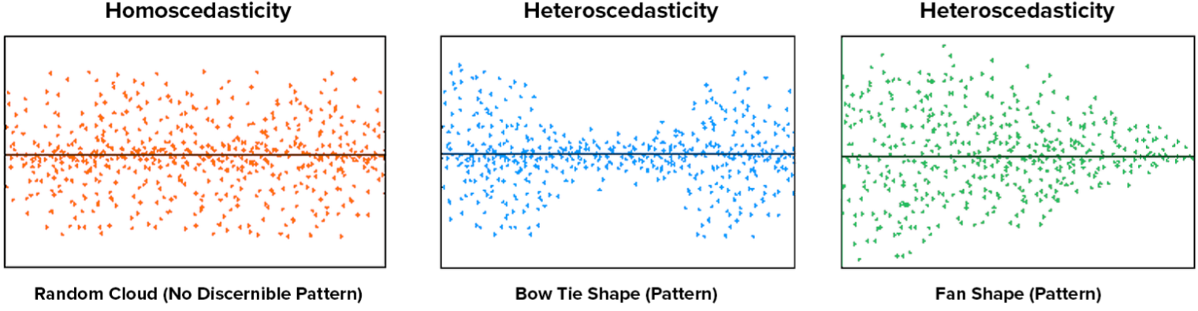
- Plot $y_{i}$ against $x_{i}$
Homoskedasticity if no discernible patterns
- Plot $ϵ_{i}$ against $x_{i}$

Assumption 4: No (Serial) Correlation
We assume that the covariance between any two error terms $ϵ_{i}$ and $ϵ_{j}$ is zero: $Cov\left(ϵ_{i}, ϵ_{j}\right)=0$.

When is correlation common?
- Correlation over time: time-series data, e.g. stock prices/interest rates/GDP: if GDP is above its mean in $t-1$ it is likely also above its mean in $t$
- Correlation due to clustering: cross-section data (unobserved characteristics captured in $ϵ_{i}$)

Assumption 5: Normality
We assume that $ϵ_{i}$ is normally distributed: $ϵ_{i}\sim N(0, σ^{2})$ or in matrix notation: $ϵ|X\sim N(0, σ^{2}I_{N} )$
important for hypothesis testing!

Summary of Assumptions
Assumption 1:
$y_{i}=x_{i}^{'}β+ϵ_{i}$, i=1, …, N
Assumptions 2-5:
$ϵ_{i}\sim N(0, σ^{2})$, $Cov\left(ϵ_{i}, ϵ_{j}\right)=0$, $i, j=1, …, N$, $i≠j$ or in matrix notation: $ϵ|X\sim N(0, σ^{2}I_{N} )$

Properties of OLS

Unbiasedness
Is the expected value of $\hat{β}$ equal to the true value of $β$, i.e., $E\left(\hat{β}\right)=β$?
$\hat{β}={\left(X^{'}X\right)}^{-1}X^{'}y$ |$y= Xβ+ϵ$ (true model)
$={\left(X^{'}X\right)}^{-1}X^{'}\left(Xβ+ϵ\right)$
$={\left(X^{'}X\right)}^{-1}X^{'}Xβ+{\left(X^{'}X\right)}^{-1}X^{'}ϵ$
$=β+{\left(X^{'}X\right)}^{-1}X'ϵ$
$E\left(\hat{β}\right)=E\left[β+{\left(X^{'}X\right)}^{-1}X^{'}ϵ\right]$ | $E\left[β\right]=β$ and $E\left[ϵ|X\right]=0$ (Assumption 2)
$=β+E\left[{\left(X^{'}X\right)}^{-1}X^{'}0\right]=β$
$E\left(\hat{β}\right)=β$ $\hat{β}$ is unbiased (if assumption 2 holds)

Efficiency
What is $V(\hat{β})$ and how does it compare with $V(\tilde{β})$ for another estimator $\tilde{β}$?
$V\left(\hat{β}\right)=E\left[\left(\hat{β}-E\hat{β}\right)\left(\hat{β}-E\hat{β}\right)'\right]$ | $E\left(\hat{β}\right)=β$
$=E\left[\left(\hat{β}-β\right)\left(\hat{β}-β\right)'\right]$ | $\hat{β}=β+{\left(X^{'}X\right)}^{-1}X'ϵ$ $\hat{β}-β={\left(X^{'}X\right)}^{-1}X'ϵ$
$=E\left[{(\left(X^{'}X\right)}^{-1}X'ϵ){(\left(X^{'}X\right)}^{-1}X'ϵ)'\right]=E\left[{\left(X^{'}X\right)}^{-1}X'ϵϵ'X{\left(X^{'}X\right)}^{-1}\right]$
$={\left(X^{'}X\right)}^{-1}X'E\left[ϵϵ'\right]X{\left(X^{'}X\right)}^{-1}$ | $E\left[ϵϵ'\right]=σ^{2}I_{N}$ (Assumptions 3 and 4)
$={\left(X^{'}X\right)}^{-1}X'\left(σ^{2}I_{N}\right)X{\left(X^{'}X\right)}^{-1}$
$=σ^{2}{\left(X^{'}X\right)}^{-1}(X^{'}X){\left(X^{'}X\right)}^{-1}=σ^{2}{\left(X^{'}X\right)}^{-1}$
$V\left(\hat{β}\right)=σ^{2}{\left(X^{'}X\right)}^{-1}=\frac{1}{N-1}σ^{2}{\left(\frac{1}{N-1}X^{'}X\right)}^{-1}$, where ${\left(\frac{1}{N-1}X^{'}X\right)}^{-1}$ is the inverse of the “sample variance-covariance matrix”
3 factors influencing $V\left(\hat{β}\right)$: sample size $(N-1)$: $(N-1)$↑ $V\left(\hat{β}\right)$↓
variance of $ϵ_{1}$: $σ^{2}$: $σ^{2}$↓ $V\left(\hat{β}\right)$↓
sample variance-covariance-matrix $\frac{1}{N-1}(X^{'}X)$: $\frac{1}{N-1}(X^{'}X)$↑ $V\left(\hat{β}\right)$↓
(because: if $\frac{1}{N-1}(X^{'}X)$ is large, there is much “spread” in the distribution of $x_{i}$, therefore, it is easier to get the “right” regression line)

Sampling Distribution
What is the distribution of $\hat{β}$? Assumption 5 assumes a normal distribution

Properties of OLS under the Five Assumptions

Gauss-Markov Theorem
Under assumptions 1 to 4, the estimator $\hat{β}$ is the…
Best (smallest variance of all unbiased estimators, i.e. $V\left(\tilde{β}\right)-V\left(\hat{β}\right)$ is pos. semidef. matrix $∀\tilde{β}$)
Linear (a linear function of $y_{i}$, i.e. $\hat{β}=\sum{w_{i}y_{i}}$, where $w_{i}={\left(x_{i}x_{i}^{'}\right)}^{-1}x_{i}$ is a $K×1$ vector of weights)
Unbiased (i.e. $E\left(\hat{β}\right)=β$)
Estimator

Normality
Under assumption 5, $\hat{β}$ is normally distributed: $\hat{β}\sim N(β, σ^{2}{\left(X^{'}X\right)}^{-1})$
(Because we know that $E\left(\hat{β}\right)=β$, $V\left(\hat{β}\right)=σ^{2}{\left(X^{'}X\right)}^{-1}$ and $\hat{β}=β+{\left(X^{'}X\right)}^{-1}X^{'}ϵ=β+{\left(\sum{x_{i}x_{i}^{'}}\right)}^{-1}\sum{x_{i}ϵ_{i}}$ is a linear combination of $ϵ_{i}$’s and therefore also normally distributed)

Value of the Assumptions
Two complementary views of $\hat{β}$ from OLS regression
- way to calculate $E(y_{i}|x_{i})$ correlation ”statistical” interpretation always valid
- way to estimate the effect of a change in $x_{i}$ on $y_{i}$ causation ”economic” interpretation
CLRM assumptions allow to interpret correlations as causal effects!

Evaluation of the Assumptions
Ask for each property:
- How likely violated?
- What is the consequence if violated?
- How to fix if violated?

Assumption 1: Linearity
(A1) $y_{i}=x_{i}^{'}β+ϵ_{i}, i=1, …, N$
- Is it likely to be violated?
Almost surely, because the world is rarely truly linear.
- What are the consequences if it is violated?
We will estimate the approximate effect of $x_{ik}$ on $y_{i}$ (because the linear function is a “first-order approximation of any nonlinear function”)
- How do we fix it if violated?
Estimate a model with nonlinear with e.g. $\log\left(x_{ik}\right)$, $x_{ik}^{2}$, interactions between $x_{ij}$ and $x_{ik}$, etc.

Assumption 2: Mean-Zero Error
(A2) $E(ϵ_{i}|x_{i})=0$
- Is it likely to be violated?
It certainly can be, then we say “$x_{i}$ is correlated with the error term” or “$x_{ik}$ is endogenous”
Common reasons for endogeneity
- Simultaneous causality ($x_{ik}$ causes a change in $y_{i}$, but $y_{i}$ also causes a change in $x_{ik}$)
- Correlated unobservables (third variable, $w_{i}$, causes changes in both $x_{ik}$ and $y_{i}$)
- Measurement error in $x_{ik}$
- What are the consequences if it is violated?
$\hat{β}$ is biased: we will not estiamte the causal effect of $x_{ik}$ on $y_{i}$ serious trouble!!!
- How do we fix it if violated?
e.g. Instrumental Variables (IV), Panel Data Methods…

Assumption 3 and 4: Homoskedasticity and No Correlation
(A3 & A4) $V(ϵ)=σ^{2}I_{N}$
- Is it likely to be violated?
Can be, if 1. errors vary with features of explanatory variables (e.g. impact of income on consumption)
2. errors are correlated across observations (e.g. clustering)
- What are the consequences if it is violated?
Not a big deal, because $\hat{β}$ is still unbiased, only $V(\hat{β})$ is biased (wrong standard errors)
- How do we fix it if violated?
Use the right formula for $V(\hat{β})$ or estimate a model via Generalized Least Squares

Assumption 5: Normality
(A5) $ϵ_{i}\sim N(0, σ^{2})$
- Is it likely to be violated?
No, because averages of independent random variables tend to be normally distributed (“Central Limit Theorem”)

Interpretation of the Classical Linear Regression Model

Interpretation of Multiple Regression Coefficients ${\hat{β}}_{K}$

Conceptual Interpretation

Correlational Interpretation
${\hat{β}}_{K}$ measures the partial correlation between $y_{i}$ and $x_{ik}$, i.e. the correlation between $y_{i}$ and $x_{ik}$, controlling for $x_{i, -k}$

“Causal” Interpretation
${\hat{β}}_{K}$ measures the causal effect on $y_{i}$ from a one-unit change in $x_{ik}$ (if Assumption 2: Mean-Zero Error is satisfied!)

Practical Interpretation
Partial derivative of $E(y_{i}|x_{i})$: $\frac{∂E(y_{i}|x_{i})}{∂x_{ik}}=\frac{∂\left[β_{1}+2x_{i2}+…+β_{K}x_{iK}\right]}{∂x_{ik}}=β_{k}$
$β_{k}$ measures the change in the expected value of $y_{i}$ when we change $x_{ik}$ by a small amount, controlling for (i.e. holding fixed) the other variables in the regression
$β_{k}$ is the marginal effect of $x_{ik}$ on $y_{i}$
${\hat{β}}_{k}$ is the estimate of the marginal effect of $x_{ik}$ on $y_{i}$
Other Perspective
${\hat{y}}_{i}={\hat{β}}_{1}+{\hat{β}}_{1}x_{2i}+{\hat{β}}_{3}x_{3i}$
approximation of total derivative of ${\hat{y}}_{i}$: $Δ{\hat{y}}_{i}={\hat{β}}_{2}Δx_{2i}+{\hat{β}}_{3}Δx_{3i}$
if we hold $Δx_{3i}$ constant: $Δ{\hat{y}}_{i}={\hat{β}}_{2}Δx_{2i}$
${\hat{β}}_{2}$ measures the change in ${\hat{y}}_{i}$ for a change in $x_{2i}$

Mathematical Interpretation

Some Concepts and Definitions

The Projection Matrix ($P_{x}$)
$$P_{x}$$
$\hat{β}={\left(X^{'}X\right)}^{-1}X^{'}y$

$P_{x}={\left(X^{'}X\right)}^{-1}X^{'}$ is an $N×N$ “idempotent” matrix
$P_{x}$ gives the fitted value of <whatever> when you regress <whatever> on X
e.g. $P_{x}y$ is the fitted value of $y$ when you regress it on $X$

The Residual Maker
Residual $e=y-X\hat{β}=y-X{\left(X^{'}X\right)}^{-1}X^{'}y=\left(I_{N}-X{\left(X^{'}X\right)}^{-1}X^{'}\right)y=M_{x}y$
$$M_{x}$$

$M_{x}=I_{N}-X{\left(X^{'}X\right)}^{-1}X^{'}$ is an $N×N$ “idempotent” matrix
$M_{x}$ gives the residual of <whatever> when you regress <whatever> on X
e.g. $M_{x}y$ is the residual of $y$ when you regress it on $X$

Properties of $P_{x}$ and $M_{x}$
- Square and symmetric: $P_{x}=P_{x}^{'}$ and $M_{x}=M_{x}^{'}$
- Idempotent: $P_{x}P_{x}=P_{x}$ and $M_{x}M_{x}=M_{x}$ (other example of idempotent matrix: identity matrix)

Partition of $X$ and $β$
We care most about ${\hat{β}}_{k}$ in a regression ”partition” $X$ into $X_{k}$ and $X_{-k}$:
$X=X_{k}+X_{-k}$, where $X_{k}$ is $N×1$ and $X_{-k}$ is $N×\left(K-1\right)$
We partition $β$ similarly into $β_{k}$ and $β_{-k}$:
$β=β_{k}+β_{-k}$, where $β_{k}$ is $1×1$ and $β_{-k}$ is $(K-1)×1$

Partitioned Regression (using projection matrix, residual maker)
$y=Xβ+ϵ=X_{k}β_{k}+X_{-k}β_{-k}+ϵ$
$\hat{β}=\left[\begin{matrix}{\hat{β}}_{k} \\ {\hat{β}}_{-k}\end{matrix}\right]={\left(X'X\right)}^{-1}X^{'}y={\left[\begin{matrix}X_{k}^{'}X_{k} & X_{k}^{'}X_{-k} \\ X_{-k}^{'}X_{k} & X_{-k}^{'}X_{-k}\end{matrix}\right]}^{-1}\left[\begin{matrix}X_{k}^{'}y \\ X_{-k}^{'}y\end{matrix}\right]=\left[\begin{matrix}{\left(X_{k}^{'}M_{-k}X_{k}\right)}^{-1}X_{k}^{'}M_{-k}y \\ {\left(X_{-k}^{'}M_{k}X_{-k}\right)}^{-1}X_{-k}^{'}M_{k}y\end{matrix}\right]$
${\hat{β}}_{k}={\left(X_{k}^{'}M_{-k}X_{k}\right)}^{-1}X_{k}^{'}M_{-k}y$
Define: $y^{*}≡M_{-k}y$ (= residuals of regression of $y$ an all $x$ but $x_{k}$), dimension: $(N×1)$
$X_{k}^{*}≡M_{-k}X_{k}$ (=residuals of regression of $x_{k}$ on all other $x$), dimension: $(N×1)$
${\hat{β}}_{k}={\left(X_{k}^{'}M_{-k}X_{k}\right)}^{-1}X_{k}^{'}M_{-k}y$ |$M_{-k}=M_{-k}M_{-k}$ (because it is idempotent)
$={\left(X_{k}^{'}M_{-k}M_{-k}X_{k}\right)}^{-1}X_{k}^{'}M_{-k}M_{-k}y$ | $M_{-k}={M_{-k}}^{'}$ (because it is symmetric)
$={\left(X_{k}^{'}{M_{-k}}^{'}M_{-k}X_{k}\right)}^{-1}X_{k}^{'}{M_{-k}}^{'}M_{-k}y$
$={\left(X_{k}^{*^{'}}X_{k}^{*}\right)}^{-1}X_{k}^{*^{'}}y^{*}$
k^{th} coefficient in multiple OLS regression is equivalent to coefficient in a simple OLS regression of the residual from a regression of $y$ on all other regressors ($y^{*}≡M_{-k}y$) on the residual from a regression of $X_{k}$ on all the other regressions ($X_{k}^{*}≡M_{-k}X_{k}$)
in this sense, including other covariates, $X_{-k}$, in a regression “controls for” these covariates

The Constant Term
$x_{i1}=1$ $X_{k}=ι=\left[\begin{matrix}1 \\ \begin{matrix}⋮ \\ 1 \\ ⋮\end{matrix} \\ 1\end{matrix}\right]$
Residual maker $M_{-k}$ for constant term: $M_{ι}$ $=I_{N}-ι{\left(ι^{'}ι\right)}^{-1}ι'$ |$ι^{'}ι=\sum_{i=1}^{N}{1}=N$
$=I_{N}-ιN^{-1}ι'$ |$N^{-1}=\frac{1}{N}$
$=I_{N}-ι\frac{1}{N}ι'$
Dependent and explanatory variables when controlling for $X_{-k}$:
$y^{*}=M_{-k}y=M_{ι}y=\left(I_{N}-ι{\left(ι^{'}ι\right)}^{-1}ι'\right)y=\left(I_{N}-ι\frac{1}{N}ι'\right)y$ |$ι^{'}y=\sum_{i=1}^{N}{y_{i}}$ (if y is a $N×1$ vector)
$=I_{N}y-ι\frac{1}{N}ι'y=I_{N}y-ι\frac{1}{N}\sum{y_{i}}$ |$\frac{1}{N}\sum_{i=1}^{N}{y_{i}}=\overline{y}$
$=I_{N}y-ι\overline{y}=y-\overline{y}$
$X_{k}^{*}=M_{-k}X_{k}=M_{ι}X_{k}=\left(I_{N}-ι{\left(ι^{'}ι\right)}^{-1}ι\right)X_{k}=\left(I_{N}-ι\frac{1}{N}ι'\right)X_{k}$ |$ι^{'}X_{k}=\sum_{k=1}^{N}{X_{k}}$ (if $X_{k}$ is a $N×1$ vector)
$=I_{N}X_{k}-ι\frac{1}{N}ι^{'}X_{k}=I_{N}y-ι\frac{1}{N}\sum{X_{k}}$ |$\frac{1}{N}\sum_{i=1}^{N}{X_{k}}=\overline{X}$
$=I_{N}X_{k}-ι\overline{X}=X-\overline{X}$
including a constant term “mean-deviates” all the other variables in the model!!!
Coefficient for the constant term: ${\hat{β}}_{1}=\overline{y}-{\overline{X}}_{-1}^{'}{\hat{β}}_{-1}$
i.e. constant term is set such that the average of $X_{i}'$ times ${\hat{β}}_{-1}$ equals the average of $y$
it gives the expected value of $y_{i}$ when all $x_{i}$ are zero
Including a constant term does not force the sample regression to go through the origin (which would bias all other coefficients if it is wrong to assume that is goes through the origin)
NOT include constant term: time-series models of $Δy_{t}$ on $Δx_{t}$ (constant implies “ever-growth”)

Multicollinearity

Perfect Multicollinearity
= perfect linear combination among the explanatory variables (Stata/R just drop one variable)
in summation notation: ${\hat{β}}_{2}=\frac{\sum{\left(x_{i}-\overline{x}\right)\left(y_{i}-\overline{y}\right)}}{\sum{{\left(x_{i}-\overline{x}\right)}^{2}}}$ $\sum{{\left(x_{i}-\overline{x}\right)}^{2}}≠0$ $x_{i}≠\overline{x}$, i.e. not only one $x_{i}$
in matrix notation: $β={\left(X^{'}X\right)}^{-1}X'y$ $X^{'}X$ must be invertible

Near-Perfect Multicollinearity
= near-perfect linear combination among the explanatory variables
high standard error (because not much variation in $x_{i}$ left when controlling for multi-collinear variable)

Hypothesis Testing in the CLRM
to tell us whether the signs and magnitude of the estimated coefficients are statistically significant

Goodness of Fit

Model Selection: Within-Sample Fit vs. Out-of-Sample Fit
If goal of economic analysis is…
…determining the variables individual significance (causal analysis) within-sample fit
…prediction out-of-sample fit

Within-Sample Fit of a Regression
measure how well we fit $y_{i}$ with ${\hat{y}}_{i}=x_{i}'\hat{β}$ (and how well we failed to fit $e_{i}$ with our residual ${\hat{e}}_{i}$)

R²
= “coefficient of determination” = measure of the overall within-sample fit of a regression
How much of the variance of $y_{i}$ can be explained by the model?
If you got a new $x_{i}$ and predicted ${\hat{y}}_{i}$, how close is the predicted ${\hat{y}}_{i}$ to the true $y_{i}$?

TSS, ESS and RSS
Including a constant term mean-deviates all other variables
sample means of $y$ and $\hat{y}$: $\overline{y}=\frac{1}{N}\sum{y_{i}}$ and $\overline{\hat{y}}=\frac{1}{N}\sum{{\hat{y}}_{i}}$
mean-deviates of $y$ and $\hat{y}$: ${\tilde{y}}_{i}=y_{i}-\overline{y}$ and ${\tilde{\hat{y}}}_{i}={\hat{y}}_{i}-\overline{\hat{y}}$
Total Sum of Squares (TSS): $TSS$ $=\sum{{\tilde{y}}_{i}^{2}}$ (summation natation)
$=\tilde{y}'\tilde{y}$ (matrix notation)
Explained Sum of Squares (ESS): $ESS$ $=\sum{{\tilde{\hat{y}}}_{i}^{2}}$ (summation natation)
$=\tilde{\hat{y}}'\tilde{\hat{y}}$ (matrix notation)
Residual Sum of Squares (RSS): $RSS$ $=\sum{e_{i}^{2}}$ (summation natation)
no mean-deviation, because: mean 0
$=e'e$ (matrix notation)
If there is a constant term in the regression:
${\tilde{y}}^{'}\tilde{y}={\tilde{\hat{y}}}^{'}\tilde{\hat{y}}+e'e$ $TSS=ESS+RSS$
$R^{2}=\frac{{\tilde{\hat{y}}}^{'}\tilde{\hat{y}}}{{\tilde{y}}^{'}\tilde{y}}=\frac{ESS}{TSS}$
$=1-\frac{e^{'}e}{{\tilde{y}}^{'}\tilde{y}}=1-\frac{RSS}{TSS}$ (if there is a constant term in the regression!)
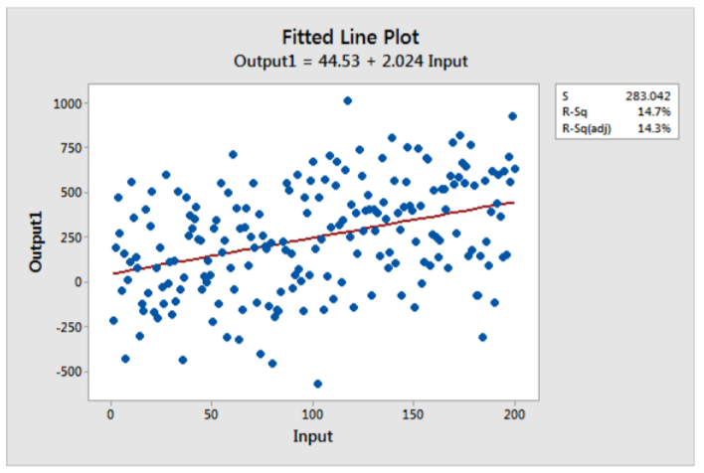
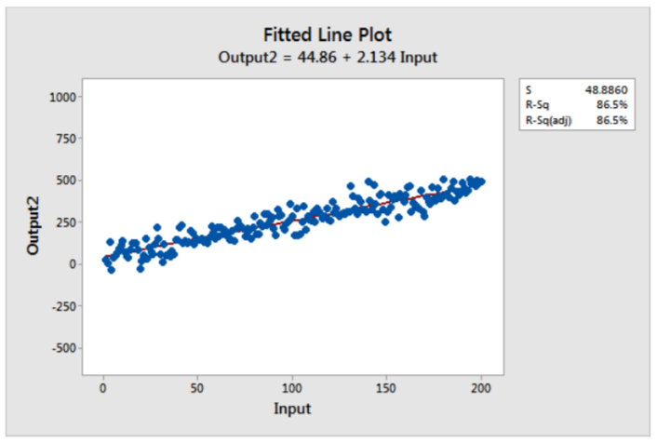
High R²: Low R²:

Dangers of R²
- Different types of data imply different “typical” values of R²:
- Cross-section data: low R² (lots of stuff)
- Time-series data: high R²
- Different functional forms for $y_{i}$ can change R²:
$\log\left(y_{i}\right)$ has higher R² than $y_{i}$ (because $\log{()}$ has lower variability lower TSS higher R²)
- Adding explanatory variables to a model always increases R² but adding variables is “overfitting” adds nonlinearities use adjusted R²

Adjusted R²
= R², which penalizes for including variables that do not contribute to the overall explanatory power, i.e. variable $x_{ik}$ that does not reduce SSR increases ${\overline{R}}^{2}$ ($K↑ →\left(N-K\right)↓ →e’\frac{e}{N-K}↑→{\overline{R}}^{2}↓$)
${\overline{R}}^{2}$ increases if absolute value of t-statistic of parameter associated with regressor is greater than one
formula as R², but adjusted for the number of “degrees of freedom” in each of the RSS and TSS:
${\overline{R}}^{2}=1-\frac{e^{'}e/(N-K)}{{\tilde{y}}^{'}\tilde{y}/(N-1)}$

Out-of-Sample Fit of a Regression

Cross Validation
k-fold cross validation:
- Divide the data into $k$ (e.g. 5, 10, N-1) roughly equal subsets (“folds”)
index them by s=1, …, k
- For each s: 1. Fit your model using the k-1 subsets other than s
2. Predict your model on subset s and measure your loss L_{s}
repeat for each subset
- Evaluate the loss of the model: $\overline{L}=\frac{1}{k}\sum{L_{s}}$
- Select the model with the smallest overall loss

Hypothesis Testing
we want to know something about $β_{k}$, based on our estimate ${\hat{β}}_{k}$ (significance)

Introduction
Two different methods:

Interval Estimation
= create an interval within which we expect $β_{k}$ to lie:
- Treat ${\hat{β}}_{k}$ as the best estimate of $β_{k}$
- Use $V\left(β_{k}\right)$ to construct lower and upper bounds withing which we believe $β_{k}$ lies with high probability

Hypothesis Testing
= ask if estimator ${\hat{β}}_{k}$ is “compatible” with some specific value of the population parameter $β_{k}$:
- Suppose $β_{k}$ is s specific value (e.g. $β_{k}=2$)
- Evaluate the probability of seeing the ${\hat{β}}_{k}$ we see under this assumption
- If unlikely, reject the hypothesis that $β_{k}$ is the specific value

we know the distribution of $\hat{β}$: $\hat{β}\sim N\left(β, σ^{2}{\left(X^{'}X\right)}^{-1}\right)$
distribution of any element of $\hat{β}$, ${\hat{β}}_{k}$: ${\hat{β}}_{k}\sim N\left(β, σ^{2}{\left(X^{'}X\right)}_{kk}^{-1}\right)$ (k^{th} element of ${\left(X^{'}X\right)}^{-1}$)
we do NOT know $V\left(\hat{β}\right)= σ^{2}{\left(X^{'}X\right)}^{-1}$

Estimating $V\left(\hat{β}\right)$
- Use the formula $V\left(\hat{β}\right)= σ^{2}{\left(X^{'}X\right)}^{-1}$
a. Estimate $σ^{2}$: $σ^{2}$ is the variance of $ϵ_{i}$ ($ϵ_{i}\sim (0, σ^{2})$) $e_{i}={\hat{ϵ}}_{i}=y_{i}-x_{i}^{'}β$
Maximum Likelihood estimator: $s_{MLE}^{2}=\frac{1}{N}\sum{e_{i}^{2}}$ (summation notation)
$s_{MLE}^{2}=\frac{e^{'}e}{N}$ (biased) (in matrix notation)
Unbiased estimator: $s^{2}=\frac{e^{'}e}{N-K}$
b. Use the formula and insert the estimated $σ^{2}$
- “Bootstrapping”
use bootstrapping if: explanatory variables are fitted values (formula ignores error from fitting)
bootstrapping is easier than doing the asymptotic math
asymptotic approximation are poor, e.g. if unit root in time series data
”Nonparametric bootstrap”:
= sampling from the empirical distribution of the observation
(i.e. take B samples of data from the population (or the sample) and ran OLS on all samples and use empirical distribution of $\hat{β}$ ${\hat{V}}_{boot}\left({\hat{β}}_{k}\right)=\frac{1}{B-1}{\sum_{b=1}^{B}{\left({\hat{β}}_{b, k}-{\overline{\hat{β}}}_{k}\right)}}^{2}$
How to do bootstrapping?
1. Let $w_{i}^{'}=\left[y_{i} x_{i}^{'}\right]$. Given data $w_{i}$, i=1, …, N, draw a bootstrap sample of size N
2. Calculate an appropriate statistic using the bootstrap sample, e.g. ${\hat{β}}_{b}$
3. Repeat (1) and (2) B times
4. Calculate a bootstrapped version of the statistic of interest, e.g. $stderr_{boot, k}=\sqrt{{\hat{V}}_{boot}({\hat{β}}_{k})}$
“Parametric bootstrap”
=sampling from the fitted distribution of a statistic
How to do bootstrapping?
1st Case: $y|x\sim F\left(x, β\right)$, estimate $\hat{β}$ use original $x_{i}$ and generate $y_{i}$ from random draws of $F\left(x, \hat{β}\right)$
2nd Case: $y_{i}=g\left(x_{i}, β\right)+ϵ_{i}$, $\hat{β}$ construct $e_{i}$, sample from $e_{i}$ and construct $y_{i}=g\left(x_{i}, \hat{β}\right)+e_{i}$
How many samples should we bootstrap?
Cameron and Trivedi (2005)
$B=384ω$, where $ω=\frac{2+γ_{4}}{4}$, and $γ_{4}$ is the coefficient of excess kurtosis for the bootstrap estimator ${\hat{β}}_{b}$
Efron and Tibsharani (1993)
200 is almost always enough

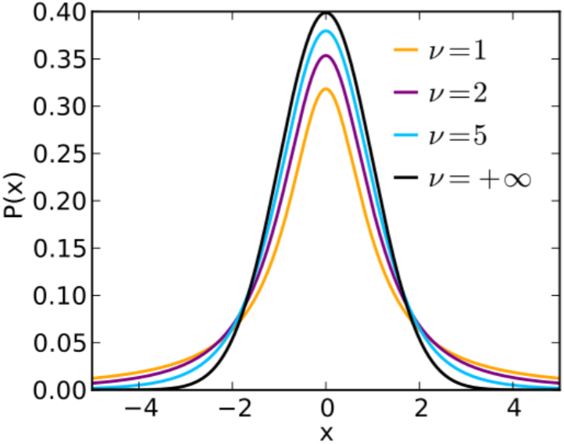

Consequence of estimating $V\left(\hat{β}\right)$:
$\hat{β}\sim N\left(β, σ^{2}{\left(X^{'}X\right)}^{-1}\right)$ suggest using a normal distribution
BUT estimated $σ^{2}$ use t-distribution (with $v$ degrees of freedom)

Types of Hypothesis Tests
- Single hypothesis involving a single coefficient, e.g. $β_{k}=2$
t test
- Single hypothesis involving multiple coefficients, e.g. $β_{j}=β_{k}$
- Multiple hypotheses involving a single coefficient, e.g. $β_{j}=0$ and $β_{k}=2$
F test
or multiple coefficients, e.g. $β_{j}=0$ and $β_{k}=β_{l}$

Interval Estimation
= create an interval within which we expect $β_{k}$ to lie with probability $\left(1-α\right)$:
- Treat ${\hat{β}}_{k}$ as the best estimate of $β_{k}$
- Use $V\left(β_{k}\right)$ to construct lower and upper bounds within which we believe $β_{k}$ lies with high probability:
  - Calculate bounds (”critical values”) for a t distribution with $N-K$ decrees of freedom (given $α$):
$P(-{\overline{t}}_{α/2}≤t_{N-K}≤{\overline{t}}_{α/2})=1-α$
  - “Standardize” the distribution of ${\hat{β}}_{k}$: ${\hat{β}}_{k}\sim N\left(β_{k}, σ^{2}{\left(X^{'}X\right)}_{kk}^{-1}\right)$
$\frac{{\hat{β}}_{k}-β_{k}}{σ\sqrt{{\left(X^{'}X\right)}_{kk}^{-1}}}\sim N\left(0, 1\right)$
$\frac{{\hat{β}}_{k}-β_{k}}{s\sqrt{{\left(X^{'}X\right)}_{kk}^{-1}}}\sim t_{N-K}$ or $\frac{{\hat{β}}_{k}-β_{k}}{stderr\left({\hat{β}}_{k}\right)}\sim t_{N-K}$
  - Plug (2) into (1) to obtain a confidence interval for $β_{k}$:
(2) $\boxed{\frac{{\hat{β}}_{k}-β_{k}}{s\sqrt{{\left(X^{'}X\right)}_{kk}^{-1}}}\sim t_{N-K}}$
(1) $P(-{\overline{t}}_{1-α/2}≤\boxed{t_{N-K}}≤{\overline{t}}_{1-α/2})=1-α$
$P(-{\overline{t}}_{1-α/2}≤\frac{{\hat{β}}_{k}-β_{k}}{s\sqrt{{\left(X^{'}X\right)}_{kk}^{-1}}}≤{\overline{t}}_{1-α/2})=1-α$
$P(-{\overline{t}}_{1-α/2}s\sqrt{{\left(X^{'}X\right)}_{kk}^{-1}} ≤{\hat{β}}_{k}-β_{k}≤{\overline{t}}_{1-α/2}s\sqrt{{\left(X^{'}X\right)}_{kk}^{-1}})$ $=1-α$
$P(-{\hat{β}}_{k}-{\overline{t}}_{1-α/2}s\sqrt{{\left(X^{'}X\right)}_{kk}^{-1}} ≤-β_{k}≤-{\hat{β}}_{k}+{\overline{t}}_{1-α/2}s\sqrt{{\left(X^{'}X\right)}_{kk}^{-1}})$ $=1-α$
$P({\hat{β}}_{k}+{\overline{t}}_{1-α/2}s\sqrt{{\left(X^{'}X\right)}_{kk}^{-1}}≥β_{k}≥{\hat{β}}_{k}-{\overline{t}}_{1-α/2}s\sqrt{{\left(X^{'}X\right)}_{kk}^{-1}})$ $=1-α$
$P({\hat{β}}_{k}+{\overline{t}}_{1-α/2}s\sqrt{{\left(X^{'}X\right)}_{kk}^{-1}}≥β_{k}≥{\hat{β}}_{k}-{\overline{t}}_{1-α/2}s\sqrt{{\left(X^{'}X\right)}_{kk}^{-1}})$ $=1-α$
$P({\hat{β}}_{k}-{\overline{t}}_{1-α/2}s\sqrt{{\left(X^{'}X\right)}_{kk}^{-1}}≤β_{k}≤{\hat{β}}_{k}+{\overline{t}}_{1-α/2}s\sqrt{{\left(X^{'}X\right)}_{kk}^{-1}})$ $=1-α$
Example: $α=0.05$ und $N-K=100$:
$({\hat{β}}_{k}-1.984⋅s\sqrt{{\left(X^{'}X\right)}_{kk}^{-1}}≤β_{k}≤{\hat{β}}_{k}+1.984⋅s\sqrt{{\left(X^{'}X\right)}_{kk}^{-1}})$ $=1-0.05=0.95=95\%$

Hypothesis Testing
= ask if estimator ${\hat{β}}_{k}$ is “compatible” with some specific value of the population parameter $β_{k}$:
- Explicitly define two opposing hypotheses: H₀ and H₁ one-tailed or two-tailed test
- Construct a test statistic under the null hypothesis (usually standardized distribution of $\hat{β}$)
${\tilde{t}}_{N-K}=\frac{{\hat{β}}_{k}-β_{k}}{stderr\left({\hat{β}}_{k}\right)}$
Critical value path:
- Select a level of significance, $α$, and calculate its critical value (from t-distribution table)
for one-tailed test: ${\overline{t}}_{1-α,N-K}$
for two-tailed test: ${\overline{t}}_{1-\frac{α}{2}, N-K}$
- Compare the value of the test statistic to the critical value:
if $\left|\tilde{t}\right|>critival value$: reject H₀
if $\left|\tilde{t}\right|≤critival value$: fail to reject H₀ (never “accept” H₀!)
p-value path:
- Calculate the probability of getting a value of the test statistic as big as it is if H₀ is true
p-value (cannot be calculated by hand!)
- Compare this probability (p-value) to the desired level of significance:
if $p-value≤α$: reject H₀
if $p-value>α$: fail to reject H₀

Example
Model: $vfr_{it}=α+β_{1}beertax_{it}+β_{2}unemp_{it}+…+β_{5}vmiles_{it}+u_{i}$, N=336, K=6
OLS result: $vfr_{it}=1.771+0.094 beertax_{it}+0.016 unemp_{it}+…+u_{i}$,
$\left(0.949\right) \left(0.116\right) (0.025)$
Hypothesis testing
Test the hypothesis that $β_{1}=0$:
- H₀: $β_{1}=0$, H₁: $β_{1}≠0$ two-tailed (set H₀ to be the thing you do NOT want!)
Test statistic:${\tilde{t}}_{N-K}=\frac{{\hat{β}}_{k}-β_{k}}{stderr\left({\hat{β}}_{k}\right)}$: ${\tilde{t}}_{336-6}={\tilde{t}}_{330}=\frac{{\hat{β}}_{1}-β_{1}}{stderr\left({\hat{β}}_{1}\right)}=\frac{0.094-0}{0.116}=0.810$
Critical value path:
- Select level of significance: $α=5\%=0.05$
critical value: ${\overline{t}}_{1-\frac{α}{2},N-K}={\overline{t}}_{1-\frac{0.05}{2},336-6}={\overline{t}}_{0.975,330}=1.967$ (from t-distribution table)
- Compare value of test statistic to critical value:
$\tilde{t}=0.810<{\overline{t}}_{0.975}=1.967$ fail to reject H₀
p-value path:
- Calculate probability of getting a value of the test statistic as big as it is if H₀ is true:
$P\left(\left|t_{N-K}\right|≥\tilde{t}\right)=P\left(\left|t_330\right|≥0.810\right)=0.4185$ (p-value)
- Compare p-value and $α$:
$p-value=0.4185>0.05≤α$ fail to reject H₀

More Complicated Hypothesis Testing

Single Hypothesis Involving Multiple Coefficients
e.g. $β_{j}=β_{k}$ t-test BUT deriving distribution of test statistic more complicated:
- Explicitly define two opposing hypotheses: H₀ and H₁
- Construct a test statistic under the null hypothesis (=standardized distribution of ${\hat{β}}_{j}-{\hat{β}}_{k}$):
Distribution of ${\hat{β}}_{2}-{\hat{β}}_{3}$:
$E\left[{\hat{β}}_{j}-{\hat{β}}_{k}\right]=E\left({\hat{β}}_{j}\right)-E\left({\hat{β}}_{k}\right)=β_{j}-β_{k}$
$V\left[{\hat{β}}_{j}-{\hat{β}}_{k}\right]=V\left({\hat{β}}_{j}\right)+V\left({\hat{β}}_{k}\right)-2Cov\left({\hat{β}}_{j}, {\hat{β}}_{k}\right)=σ^{2}{\left(X^{'}X\right)}_{jj}^{-1}+σ^{2}{\left(X^{'}X\right)}_{kk}^{-1}-2σ^{2}{\left(X^{'}X\right)}_{jk}^{-1}$
$=σ^{2}\left({\left(X^{'}X\right)}_{jj}^{-1}+{\left(X^{'}X\right)}_{kk}^{-1}-2{\left(X^{'}X\right)}_{jk}^{-1}\right)$
Distribution: ${\hat{β}}_{j}-{\hat{β}}_{k}\sim N\left(β_{j}-β_{k},σ^{2}\left({\left(X^{'}X\right)}_{jj}^{-1}+{\left(X^{'}X\right)}_{kk}^{-1}-2{\left(X^{'}X\right)}_{jk}^{-1}\right)\right)$
…under H₀ ($β_{j}-β_{k}=0$): ${\hat{β}}_{j}-{\hat{β}}_{k}\sim N\left(0,σ^{2}\left({\left(X^{'}X\right)}_{jj}^{-1}+{\left(X^{'}X\right)}_{kk}^{-1}-2{\left(X^{'}X\right)}_{jk}^{-1}\right)\right)$
Standardized distribution: $\frac{{\hat{β}}_{j}-{\hat{β}}_{k}}{\sqrt{σ^{2}\left({\left(X^{'}X\right)}_{jj}^{-1}+{\left(X^{'}X\right)}_{kk}^{-1}-2{\left(X^{'}X\right)}_{jk}^{-1}\right)}}\sim N\left(0,1\right)$
…for estimated variance: $\frac{{\hat{β}}_{j}-{\hat{β}}_{k}-0}{\sqrt{s^{2}{\left(X^{'}X\right)}_{jj}^{-1}+{s^{2}\left(X^{'}X\right)}_{kk}^{-1}-2s^{2}{\left(X^{'}X\right)}_{jk}^{-1}}}\sim t_{N-K}$
test statistic: $\tilde{t}=\frac{{\hat{β}}_{j}-{\hat{β}}_{k}-0}{\sqrt{s^{2}{\left(X^{'}X\right)}_{jj}^{-1}+{s^{2}\left(X^{'}X\right)}_{kk}^{-1}-2s^{2}{\left(X^{'}X\right)}_{jk}^{-1}}}$
Critical value path:
- Select level of significance, $α$, and calculate the critical value (from t-distribution table):
for one-tailed test: ${\overline{t}}_{1-α,N-K}$
for two-tailed test: ${\overline{t}}_{1-\frac{α}{2}, N-K}$
- Compare value of test statistic $\tilde{t}$ to critical value $\overline{t}$:
if $\left|\tilde{t}\right|>\left|critival value\right|$: reject H₀
if $\left|\tilde{t}\right|≤\left|critival value\right|$: fail to reject H₀
p-value path:
- Calculate probability of getting a value of the test statistic as big as it is if H₀ is true:
p-value =$P\left(\left|t_{N-K}\right|≥\tilde{t}\right)$ (not easy to calculate!)
- Compare p-value and $α$:
if $p-value≤α$: reject H₀
if $p-value>α$: fail to reject H₀

Example
Model: $wage_{i}=β_{1}+β_{2}educ_{i}+β_{3}e{xp}_{i}+{\tilde{x}}_{i}'\tilde{β}+ϵ_{i}$, N=616, K=6
Is education or experience more important for someone’s wage?
Hypothesis testing:
- Hypothesis: H₀: $β_{2}= β_{3}$, H₁: $β_{2}≠β_{3}$ two-tailed
- Test statistic: $\tilde{t}=\frac{{\hat{β}}_{2}-{\hat{β}}_{3}-0}{\sqrt{s^{2}{\left(X^{'}X\right)}_{2,2}^{-1}+{s^{2}\left(X^{'}X\right)}_{3,3}^{-1}-2s^{2}{\left(X^{'}X\right)}_{2,3}^{-1}}}=\frac{0.42969-0.20710-0}{\sqrt{0.00453547+0.0010878-2⋅0.0000004686}}=\frac{0.22259}{0.07498}=2.968$
Critical value path:
- Select level of significance: $α=5\%=0.05$
critical value: ${\overline{t}}_{1-\frac{α}{2},N-K}={\overline{t}}_{1-\frac{0.05}{2},616-6}={\overline{t}}_{0.975,610}=1.964$ (from t-distribution table)
- Compare value of test statistic to critical value:$\tilde{t}=2.968>\overline{t}=1.964$ reject H₀
p-value path:
- Calculate probability of getting a value of the test statistic as big as it is if H₀ is true:
p-value=$P\left(\left|t_{N-K}\right|≥\tilde{t}\right)=P\left(\left|t_{610}\right|≥2.968\right)=0.0031$
- Compare p-value and $α$: $p-value=0.0031<0.05≤α$ reject H₀

Multiple Hypotheses Involving Single Coefficients
e.g. $β_{j}=0$ and $β_{k}=2$ F test
- Explicitly define two opposing hypotheses: H₀ and H₁
- Two models and their fits:
  - Set up the unrestricted and restricted models:
Unrestricted model not imposing the null hypothesis
Restricted model imposing the null hypothesis
if H₀ is true, the restricted model fits the data as well as the unrestricted model
  - Compare fits of the models using R² or SSR:
F statistic: $F=\frac{(SSR_{R}-SSR_{U})/q}{SSR_{U}/(N-K)}$ or $F=\frac{(R_{U}^{2}-R_{R}^{2})/q}{1-R_{U}^{2}/(N-K)}$ (q=number of restrictions)
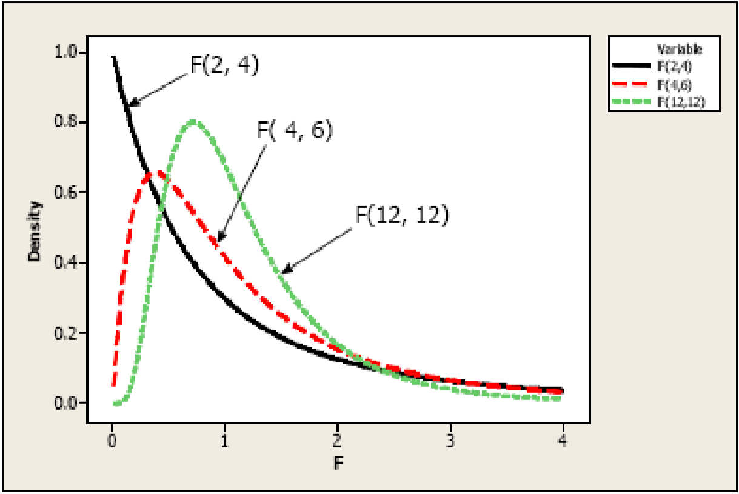
(F is distributed as an F distribution with q “numerator” degrees of freedom and (N-K) “denominator” degrees of freedom)
Critical value path:
- Select level of significance, $α$, and calculate the critical value (from table)
${\overline{F}}_{q,N-K}$
- Compare absolute value of test statistic $\tilde{t}$ to critical value $\overline{t}$
if $\left|\tilde{t}\right|>critival value$: reject H₀
if $\left|\tilde{t}\right|≤critival value$: fail to reject H₀
p-value path:
- Calculate probability of getting a value of the test statistic as big as it is if H₀ is true:
$P\left(\left|t_{N-K}\right|≥\tilde{t}\right)=…$ (p-value)
- Compare p-value and $α$:
if $p-value≤α$: reject H₀
if $p-value>α$: fail to reject H₀

Example
Model: $wage_{i}=β_{1}+β_{2}educ_{i}+β_{3}e{xp}_{i}+{\tilde{x}}_{i}'\tilde{β}+ϵ_{i}$, N=616, K=6
Hypothesis testing:
- Hypothesis: H₀: $β_{2}=0$ and $β_{3}=0$, H₁: $β_{2}≠0$ or $β_{3}≠0$
- Two models and their fits:
a. Set up the unrestricted and restricted models:
Unrestricted model: $wage_{i}=β_{1}+β_{2}educ_{i}+β_{3}e{xp}_{i}+{\tilde{x}}_{i}^{'\tilde{β}}+ϵ_{i}$
Restricted model ($β_{2}=0$ and $β_{3}=0$): $wage_{i}=β_{1}+{\tilde{x}}_{i}^{'\tilde{β}}+ϵ_{i}$
b. F statistic: $F=\frac{(R_{U}^{2}-R_{R}^{2})/2}{1-R_{U}^{2}/(616-6)}=…$
- … (see Slides4)

F always positive only one-sided tests!
For q=1: F=t-statistic^2

Specification Errors, Large Sample Theory and Bias and its Sources

Introduction

Violation of CLRM Assumptions

Violation of Assumption 2
Assumption 2: Mean-zero-error: $E\left(ϵ_{i} | x_{i}\right)=0$ or $E\left(ϵ | X\right)=0$
violated if at least one of the $x_{ik}$ is endogenous $E\left(\hat{β}\right)≠β$ $\hat{β}$ is biased/inconsistent

Violation of Other Assumptions

Violation of Assumption 1
Assumption 1: Linearity
violated if non-linear relationship use non-linear model

Violation of Assumption 3
Assumption 3: Homoskedasticity
violated if …
1. use the right standard error formula (i.e. robust standard errors), or
2. model the form of heteroskedasticity and estimate via Feasible Generalized Least Squares

Violation of Assumption 4
Assumption 4: No correlation
violated if …
1. use the right standard error formula (i.e. clustered standard errors), or
2. model the form of heteroskedasticity and estimate via Feasible Generalized Least Squares

Violation of Assumption 5
Assumption 5: Normality
no problem, because under A1-A4, $\hat{β}$ is normally distributed when samples are large

Specification Errors

Including an Irrelevant Variable
Truth: $y_{i}=β_{1}+β_{2}x_{2i}+ϵ_{i}$
$=x_{i}'β+ϵ_{i}$
$y=Xβ+ϵ$
You estimate: $y_{i}=β_{1}+β_{2}x_{2i}+β_{3}x_{3i}+ϵ_{i}$ where $β_{3}=0$ $β_{3}$ is irrelevant
$={\tilde{x}}_{i}'β+ϵ_{i}$
$y=\tilde{X}β+ϵ$

Estimate the Model
Formula for ${\hat{β}}_{k}$: ${\hat{β}}_{k}={\left(X_{k}^{'}M_{-k}X_{k}\right)}^{-1}X_{k}^{'}M_{-k}y$, where $M_{-k}=I_{N}-X_{-k}{\left(X_{-k}^{'}X_{-k}\right)}^{-1}X_{-k}^{'}$
for the model: ${\tilde{β}}_{2}={\left(X_{2}^{'}{\tilde{M}}_{-2}X_{2}\right)}^{-1}X_{2}^{'}{\tilde{M}}_{-2}y$, where $M_{-2}=I_{N}-{\tilde{X}}_{-2}{\left({\tilde{X}}_{-2}^{'}{\tilde{X}}_{-2}\right)}^{-1}{\tilde{X}}_{-2}^{'}$

Biasedness
$E\left({\tilde{β}}_{2}\right)=E\left[{\left(X_{2}^{'}{\tilde{M}}_{-2}X_{2}\right)}^{-1}X_{2}^{'}{\tilde{M}}_{-2}y\right]$ | plug in the true model: $y=Xβ+ϵ$
$=E\left[{\left(X_{2}^{'}{\tilde{M}}_{-2}X_{2}\right)}^{-1}X_{2}^{'}{\tilde{M}}_{-2}\left(Xβ+ϵ\right)\right]$ |${\tilde{M}}_{-2}Xβ={\tilde{M}}_{-2}X_{2}β_{2}$
$=E\left[{\left(X_{2}^{'}{\tilde{M}}_{-2}X_{2}\right)}^{-1}X_{2}^{'}{\tilde{M}}_{-2}\left(X_{2}β_{2}+ϵ\right)\right]$
$=β_{2}+E\left[{\left(X_{2}^{'}{\tilde{M}}_{-2}X_{2}\right)}^{-1}X_{2}^{'}{\tilde{M}}_{-2}ϵ\right]$
$=β_{2}$
Including an irrelevant variable does not cause bias!

Efficiency
True model: $V\left({\hat{β}}_{2}\right)=σ^{2}{\left(X_{2}^{'}M_{-2}X_{2}\right)}^{-1}$, where $M_{-2}=\left[ι\right]$
With an irrelevant variable$V\left({\tilde{β}}_{2}\right)=σ^{2}{\left(X_{2}^{'}{\tilde{M}}_{-2}X_{2}\right)}^{-1}$, where $M_{-2}=\left[\begin{matrix}ι & X_{3}\end{matrix}\right]$
if $X_{2}$ and $X_{3}$ are uncorrelated: $V\left({\hat{β}}_{2}\right)=V\left({\tilde{β}}_{2}\right)$
if $X_{2}$ and $X_{3}$ are correlated: $V\left({\tilde{β}}_{2}\right)>V\left({\hat{β}}_{2}\right)$
Including an irrelevant variable causes inefficiency (if the variable is correlated with another one)

Omitting a Relevant Variable
Truth: $y=Xβ+γq+ϵ$
You estimate: $y=Xβ+ϵ$

Biasedness
$E\left(\hat{β}\right)=E\left[{\left(X^{'}X\right)}^{-1}X'y\right]$ | plug in the true model: $y=Xβ+γq+ϵ$
$=E\left[{\left(X^{'}X\right)}^{-1}X'\left(Xβ+γq+ϵ\right)\right]$
$=β+E\left[γ{\left(X^{'}X\right)}^{-1}X^{'}q+{\left(X^{'}X\right)}^{-1}X'ϵ\right]$ |Assumption 2: $E\left(ϵ | X\right)=0$
$=β+γ{\left(X^{'}X\right)}^{-1}X^{'}q$ $=β+γ{\hat{β}}_{y-on.X}$
Omitting a relevant variable causes bias

Formula for Omitted Variable Bias
$E\left(\hat{β}\right)=β+γ{\hat{β}}_{y-on.X}$ $γ$ measures the impact of the omitted variable $q$ on the dependent variable $y$
${\hat{β}}_{y-on.X}$ measures the correlation between each $x_{ik}$ and $q_{i}$
no omitted variable bias if $γ=0$ (i.e. no omitted variable) or no correlation between $x_{ik}$ and $q_{i}$

What if only one element of X is correlated with q?
$X_{k}^{'}q=σ_{Kq}$, $X_{k}^{'}q=0$, $∀k=1,…,K-1$ only $X_{k}$ is correlated with $q$
Estimate of ${\hat{β}}_{k}$:
${\hat{β}}_{k}={\left(X_{k}^{'}M_{-k}X_{k}\right)}^{-1}X_{k}^{'}M_{-k}y$
$E\left({\hat{β}}_{k}\right)=E\left[{\left(X_{k}^{'}M_{-k}X_{k}\right)}^{-1}X_{k}^{'}M_{-k}y\right]$ |plug in true model: $y=Xβ+γq+ϵ$
$=E\left[{\left(X_{k}^{'}M_{-k}X_{k}\right)}^{-1}X_{k}^{'}M_{-k}\left(Xβ+γq+ϵ\right)\right]$ |$M_{-k}X=M_{-k}\left[\begin{matrix}X_{-k} & X_{k}\end{matrix}\right]=\left[\begin{matrix}0 & M_{-k}X_{k}\end{matrix}\right]$
$=E\left[{\left(X_{k}^{'}M_{-k}X_{k}\right)}^{-1}X_{k}^{'}M_{-k}\left(X_{k}β_{k}+γq+ϵ\right)\right]$ |Assumption 2$E\left(ϵ | X\right)=0$
$=β_{k}+γ{\left(X_{k}^{'}M_{-k}X_{k}\right)}^{-1}X_{k}^{'}M_{-k}q$ $γ$ measures the impact of the omitted variable $q$ on $y$
${\left(X_{k}^{'}M_{-k}X_{k}\right)}^{-1}X_{k}^{'}M_{-k}q$ is the correlation between $X_{k}$ and $q$ when controlling for all other $X$ ($X_{-k}$)
Even if only one element of X is correlated with q, all elements of $\hat{β}$ are biased (not only ${\hat{β}}_{k}$)!
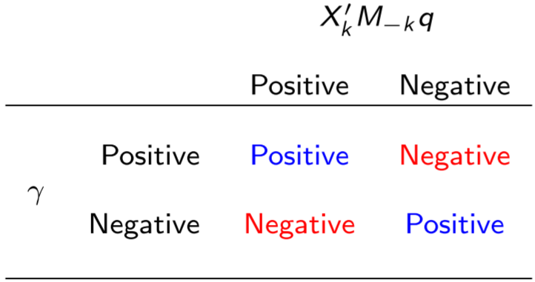
Sign of the bias:

Model: $y=β_{0}+β_{1}x_{1}+β_{2}x_{2}+ϵ$, but $x_{2}$ is omitted
${\hat{β}}_{1}=\frac{cov\left(x_{1}, y\right)}{var(x_{i})}=\frac{cov\left(x_{1}, β_{0}+β_{1}x_{1}+β_{2}x_{2}+ϵ\right)}{var(x_{i})}=β_{1}+β_{2}\frac{cov\left(x_{1},x_{2}\right)}{var(x_{i})}$ sign depends on $cov\left(x_{1},x_{2}\right)$ and $var(x_{i})$

Efficiency
Lexicographic preferences: if an estimator is biased/inconsistent, I don’t care about efficiency!

Summary Specification Error
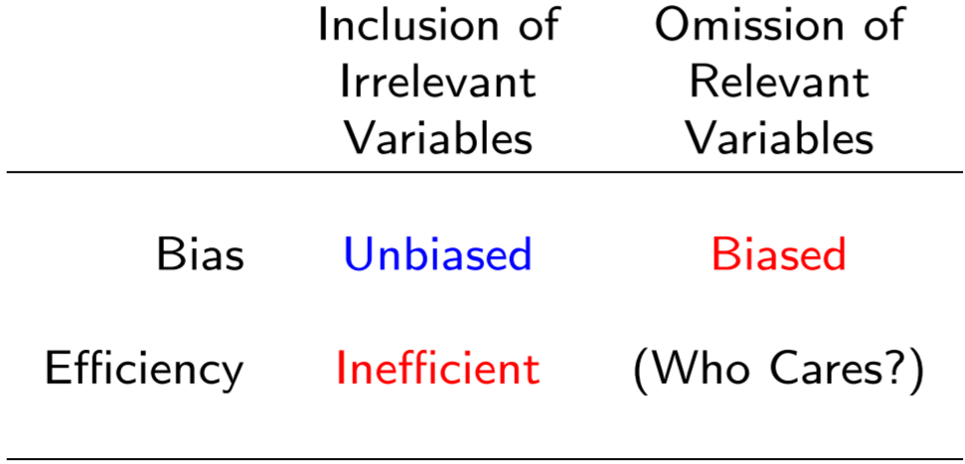 Better include an irrelevant variable, than omit a relevant one!

Large-Sample Theory
Use a general model: $y=Xβ+ϵ$ estimator $\tilde{β}$

Consistency
analogue to unbiasedness
An estimator $\tilde{β}$ is a consistent estimator of $β$ if, as $N→∞$, the sampling distribution of $\tilde{β}$ concentrates around $β$, i.e. the probability limit of $\tilde{β}$ is $β$: $\operatorname{plim}{\tilde{β}}=β$, or $\tilde{β}\underset{→}{p}β$

Conditions for Consistency
sufficient, but not necessary

Condition 1
$\lim_{N→∞}{E\left(\tilde{β}\right)}=β$, i.e. $\tilde{β}$ is asymptotically unbiased
($E\left(\tilde{β}\right)$ often won’t be a function of N $E\left(s_{MLE}^{2}\right)=\frac{N-K}{K}σ^{2}$ biased but consistent!

Condition 2
$\lim_{N→∞}{V\left(\tilde{β}\right)}=0$, i.e. the variance of $\tilde{β}$ shrinks to zero as $N→∞$

Proof:
Under assumptions 1-4: $V\left(\hat{β}\right)=\frac{1}{N}σ^{2}{\left(\frac{1}{N}X^{'}X\right)}^{-1}$
$\lim_{N→∞}{V\left(\hat{β}\right)}=\lim_{N→∞}{\frac{1}{N}σ^{2}{\left(\frac{1}{N}X^{'}X\right)}^{-1}}$ |$\lim_{N→∞}{A(N)⋅B(N)}=\lim_{N→∞}{A(N)}⋅\lim_{N→∞}{B(N)}$
$=\lim_{N→∞}{\frac{1}{N}}⋅\lim_{N→∞}{σ^{2}}⋅\lim_{N→∞}{{\left(\frac{1}{N}X^{'}X\right)}^{-1}}$

Assumption 6: Regular X’s
$\lim_{N→∞}{\frac{1}{N}X'X}=E\left(X'X\right)=Σ_{XX}$ (=finite, nonsingular matrix) constant
large sample analogue of “no perfect multicollinearity”
$=0⋅σ^{2}⋅Σ_{XX}^{-1}$
$=0$

Mathematical Underpinnings of Consistency

Two Laws of Large Numbers
- When the $X_{i}$ are independent and identically distributed with $E\left(X_{i}\right)=μ$, the Kolmogorov Law Of Large Numbers proves ${\overline{X}}_{N}\underset{→}{p}μ$
- When the $X_{i}$ are independent but non-identically distributed with $E\left(X_{i}\right)=μ_{i}$ and finite variance, the Markov Law of Large Numbers proves ${\overline{X}}_{N}\underset{→}{p}E\left({\overline{X}}_{N}\right)$

Slutsky’s Theorem
Let $\left\{x_{N}:N=1, 2, …\right\}$ be a sequence of $K×1$ random vectors such that $x_{N}\underset{→}{p}c$.
Then if $g\left(∙\right)$ is a function continuous at c, $g\left(x_{N}\right)\underset{→}{p}g\left(c\right)$, i.e. probability limits pass through nonlinear functions.
Probability expectations pass through nonlinear functions: e.g. if $\operatorname{plim}{\hat{β}=β}$ and $E\left(\hat{β}\right)=β$
$\operatorname{plim}\left(\frac{f\left(\hat{β}\right)}{g\left(\hat{β}\right)}\right)=\frac{f\left(β\right)}{g\left(β\right)}$
BUT expectations do NOT: $E\left(\frac{f\left(\hat{β}\right)}{g\left(\hat{β}\right)}\right)≠\frac{f\left(β\right)}{g\left(β\right)}$

Consistency Assumptions
Assumptions 1: Linearity
Assumption 2: Mean-zero error we only need $Cov\left(x_{i}, ϵ_{i}\right)=E\left(x_{i}ϵ_{i}\right)=0$ (in summation notation)
$=E\left(X'ϵ\right)=0$ (in matrix notation)

Asymptotic Normality
analogue to normality
Asymptotic distribution of $β$ is degenerate, i.e. it converges to a mass point at $β$ (because $V\left(\hat{β}\right)→0$ as $N→0$ and $E\left(\hat{β}\right)=β$)
not useful for hypothesis testing we want $β$ to converge to a proper distribution

From What We Know to Asymptotic Normality
$\lim_{N→∞}{V\left(\hat{β}\right)}=\lim_{N→∞}{\frac{1}{N}σ^{2}{\left(\frac{1}{N}X^{'}X\right)}^{-1}}=\lim_{N→∞}{\frac{1}{N}}⋅\left(σ^{2}Σ_{XX}^{-1}\right)$
would converge to 0 multiply by $\sqrt{N}$ variance is $\frac{N}{N}$ times a constant (matrix) constant (matrix)!
- asymptotic distribution of consistent estimator $\tilde{β}$ = distribution of $\sqrt{N}(\tilde{β}-β)$ as $N→∞$:
“$\sqrt{N}(\tilde{β}-β)$ converges in distribution to <something>”: $\sqrt{N}\left(\tilde{β}-β\right)\underset{→}{d}<something>$
”$\hat{β}$ is approxiamtely distributes as <something>”: $\hat{β}<something>$

Continuous Mapping Theorem (analog to Slutsky Theorem for Consistency)
Let $\{x_{N}\}$ be a sequence of $K×1$ random vectors such that $x_{N}\underset{→}{d}x$.
Then if $g\left(⋅\right)$ is a continuous function, then $g\left(x_{N}\right)\underset{→}{d}g(x)$.
If we can find the limiting distribution of $x_{N}$, then we can find the limiting distribution of nonlinear functions of $x_{N}$.
Asymptotic distribution of consistent $\tilde{β}$ = distribution of as $N→∞$:
$\hat{β}=β+{\left(X^{'}X\right)}^{-1}X'ϵ$ |$-β$
$\hat{β}-β={\left(X^{'}X\right)}^{-1}X'ϵ$ |$⋅\frac{N}{N}=\frac{1}{N}\frac{N}{1}= {\frac{1}{N}}^{-1}\frac{1}{N}$
$\hat{β}-β={\left(\frac{1}{N}X^{'}X\right)}^{-1}\frac{1}{N}X'ϵ$ |$⋅\sqrt{N}$
$\sqrt{N}\left(\hat{β}-β\right)={\left(\frac{1}{N}X^{'}X\right)}^{-1}\sqrt{N}\frac{1}{N}X^{'}ϵ$ |summation notation
$\sqrt{N}\left(\hat{β}-β\right)={\left(\frac{1}{N}\sum{x_{i}x_{i}^{'}}\right)}^{-1}\sqrt{N}\left(\frac{1}{N}\sum{x_{i}ϵ_{i}}\right)$
- Limiting distribution of $\hat{β}$ depends on two terms: 1. ${\left(\frac{1}{N}\sum{x_{i}x_{i}^{'}}\right)}^{-1}$ and 2. $\sqrt{N}\left(\frac{1}{N}\sum{x_{i}ϵ_{i}}\right)$
- $\sqrt{N}\left(\frac{1}{N}\sum{x_{i}ϵ_{i}}\right)$ |Assumption s A1 and A2
$\sqrt{N}\left(\frac{1}{N}\sum{x_{i}ϵ_{i}}\right)\underset{→}{d}N\left(E\left(x_{i}ϵ_{i}\right), V\left(x_{i}ϵ_{i}\right)\right)$ where $E\left(x_{i}ϵ_{i}\right)=0$
$\sqrt{N}\left(\frac{1}{N}\sum{x_{i}ϵ_{i}}\right)\underset{→}{d}N\left(0, V\left(x_{i}ϵ_{i}\right)\right)$ |A3&A4:$V\left(x_{i}ϵ_{i}\right)=E{\left(ϵ_{i}\right)}^{2}E\left(x_{i}x_{i}^{'}\right)=σ^{2}E\left(x_{i}x_{i}^{'}\right)=σ^{2}Σ_{xx}$
$\sqrt{N}\left(\frac{1}{N}\sum{x_{i}ϵ_{i}}\right)\underset{→}{d}N\left(0, σ^{2}Σ_{xx}\right)$
Applying the Continuous Mapping Theorem:
$\sqrt{N}\left(\frac{1}{N}\sum{x_{i}ϵ_{i}}\right)\underset{→}{d}N\left(0, σ^{2}Σ_{xx}\right)$ $\sqrt{N}\left(\frac{1}{N}\sum{x_{i}ϵ_{i}}\right)\underset{→}{d}N\left(0, σ^{2}Σ_{xx}^{-1}Σ_{xx}Σ_{xx}^{-1}\right)=N\left(0, σ^{2}Σ_{xx}^{-1}\right)$
$\sqrt{N}\left(\tilde{β}-β\right)N\left(0, σ^{2}{\left(\frac{1}{N}X^{'}X\right)}^{-1}\right)$ $\left(\tilde{β}-β\right)N\left(0, σ^{2}{\left(X^{'}X\right)}^{-1}\right)$
$\tilde{β}N\left(β, σ^{2}{\left(X^{'}X\right)}^{-1}\right)$

Conclusion
Under assumptions A1 Linearity and A2 Mean-zero error:
- $\hat{β}$ is consistent: $\tilde{β}\underset{→}{p}β$
- $\hat{β}$ is asymptotically normally distributed: $\sqrt{N}\left(\hat{β}-β\right)\underset{→}{d}N\left(0, .\right)$
and if A3 Homoskedasticity and A4 No Correlation hold: $\sqrt{N}\left(\hat{β}-β\right)\underset{→}{d}N\left(0, σ^{2}Σ_{XX}^{-1}\right)$
(if not, Slides 61-end) $\hat{β}N\left(β, σ^{2}{\left(X^{'}X\right)}^{-1}\right)$
no small-sample adjustments necessary: use z and $χ^{2}$ tests

Bias and its Sources
Biases are caused by endogeneity, i.e. violation of the assumption A2: $E\left(ϵ_{i}|x_{i}\right)=0$.
Three most common reasons for endogeneity:

Correlated Unobservables
= an unobserved factor determines both $y_{i}$ and $x_{ik}$
similar to omitted variable bias: $E\left(\hat{β}\right)=β+γ{\left(X^{'}X\right)}^{-1}Y^{'}q=β+γ{\hat{β}}_{q-on-X}$
e.g. “ability”: ability determines both people’s education (because it is easier for people with higher ability to get education) and income (because people with high ability perform better), but ability is usually not observed
ability is a correlated unobservable $E(ϵ_{i}|x_{i})≠0$ $E\left({\hat{β}}_{educ}\right)=β_{educ}+β_{ability}{\hat{β}}_{ability-on-educ}$
where $β_{ability}>0$ and ${\hat{β}}_{ability-on-educ}>0$ positive bias!

(Classical) Measurement Error in one of the $X_{ik}$
= an explanatory model is measured with error, where the error is uncorrelated with everything

Simple Regression Model
True model: $y_{it}=α+βx_{i}^{*}+ϵ_{i}^{*}$
but measurement error in $x_{i}=x_{i}^{*}+η_{i}$ with $η_{i}\sim \left(0, σ_{η}^{2}\right)$ and $E\left(η_{i}|x_{i}^{*}\right)=0$ and $E\left(η_{i}|ϵ_{i}^{*}\right)=0$
Estimated model: $y_{it}=α+βx_{i}^{*}+ϵ_{i}^{*}$
$y_{it}=α+βx_{i}^{*}+βη_{i}+(ϵ_{i}^{*}-βη_{i})$
$y_{it}=α+βx_{i}+ϵ_{i}$ “composite error” $ϵ_{i}=ϵ_{i}^{*}-βη_{i}$ of true and measurement error

Covariance
$Cov\left(x_{i}, ϵ_{i}\right)=Cov\left(x_{i}^{*}+η_{i}, ϵ_{i}^{*}-βη_{i}\right)$ |$Cov\left(a+b, c+d\right)=Cov\left(a, c\right)+Cov\left(a, d\right)+Cov\left(b, c\right)+Cov\left(c, d\right)$
$=Cov\left(x_{i}^{*}, ϵ_{i}^{*}\right)-Cov\left(x_{i}^{*}, βη_{i}\right)+Cov\left(η_{i}, ϵ_{i}^{*}\right)-Cov\left(η_{i}, βη_{i}\right)$
$=Cov\left(x_{i}^{*}, ϵ_{i}^{*}\right)-β⋅Cov\left(x_{i}^{*}, η_{i}\right)+Cov\left(η_{i}, ϵ_{i}^{*}\right)-β⋅Cov\left(η_{i}, η_{i}\right)$ |$Cov\left(η_{i}, η_{i}\right)=V\left( η_{i}\right)$
=0
=0
=0

$=-β⋅V\left( η_{i}\right)=-βσ_{η}^{2}$

Variance
=0
$V\left(x_{i}\right)=V\left(x_{i}^{*}+η_{i}\right)=V\left(x_{i}^{*}\right)+V\left(η_{i}\right)+2⋅Cov\left(x_{i}^{*}, η_{i}\right)$

$=V\left(x_{i}^{*}\right)+V\left(η_{i}\right)=σ_{x^{*}}^{2}+σ_{η}^{2}$ variance of true $x_{i}^{*}$ plus variance of measurement error $η$

Bias of the Beta Estimator
$\hat{β}=β+{\left(X^{'}X\right)}^{-1}X'ϵ$
$=β+\frac{\frac{1}{N}X^{'}ϵ}{\frac{1}{N}X'X}$
$\underset{→}{p} β+\frac{-βσ_{η}^{2}}{σ_{x^{*}}^{2}+σ_{η}^{2}}$
$\underset{→}{p} β\left(1-\frac{σ_{η}^{2}}{σ_{x^{*}}^{2}+σ_{η}^{2}}\right)$
$\underset{→}{p} β\left(\frac{σ_{x^{*}}^{2}}{σ_{x^{*}}^{2}+σ_{η}^{2}}\right)$
$\underset{→}{p} λβ$ where $λ=\frac{σ_{x^{*}}^{2}}{σ_{x^{*}}^{2}+σ_{η}^{2}}$ , ($0≤λ≤1)$ration of var of $x_{i}^{*}$ to total var of $x_{i}$
attenuation bias: bias towards zero

Multiple Regression Model
True model: $y_{it}=β_{1}+β_{k}x_{ik}^{*}+x_{i,-k}β_{-k}+ϵ_{i}^{*}$ with classical measurement error in $x_{ik}$

$\hat{β}=β_{k}+{\left(X^{'}M_{-k}X\right)}^{-1}X^{'}M_{-k}ϵ$
$=β_{k}+\frac{\frac{1}{N}X^{'}M_{-k}ϵ}{\frac{1}{N}X^{'}M_{-k}X}$
$\underset{→}{p} β_{k}+\frac{-β_{k}σ_{η}^{2}}{σ_{x^{*}}^{2}+σ_{η}^{2}}$
$\underset{→}{p} β\left(\frac{σ_{x_{-k}^{*}}^{2}}{σ_{x_{-k}^{*}}^{2}+σ_{η}^{2}}\right)$ $σ_{x_{-k}^{*}}^{2}$ does not change because $x_{ik}$ uncorrelated with $x_{-k}$
$σ_{x_{-k}^{*}}^{2}+σ_{η}^{2}<σ_{x^{*}}^{2}$ $\left(\frac{σ_{x_{-k}^{*}}^{2}}{σ_{x_{-k}^{*}}^{2}+σ_{η}^{2}}\right)>\left(\frac{σ_{x^{*}}^{2}}{σ_{x^{*}}^{2}+σ_{η}^{2}}\right)$
Bias larger in multiple regression model than in single regression model!

Measurement Error in y
See Problem Set 3 no bias, just larger variance!

Simultaneous Causality (Systems of Simultaneous Equations)
= not only does $x_{ik}$ cause $y_{i}$, but $y_{i}$ also causes $x_{ik}$ ($x_{ik}$ is an endogenous variable):
$y_{i}=β_{0}+β_{1}x_{ik}+ϵ_{i}$ $E\left(β_{1}\right)=β_{1}+corr(y_{i}, x_{ik})$ bias!

Example: Demand and Supply
Demand: $q_{i}=α_{0}+α_{1}p_{i}+α_{2}{inc}_{i}+ϵ_{i}$ where ${inc}_{i}$ is a demand shifter
$p_{i}$ causes $q_{i}$, but $q_{i}$ also causes $p_{i}$
$E\left({\hat{α}}_{1}\right)=α_{1}+γ⋅corr(q_{i}, p_{i})$ biased!

System of Simultaneous Equations

Endogenous variables
= variables jointly determined by the behavioral relationship under consideration ($q_{i}$, $p_{i}$)
need one equation each to be specified

Exogenous variables
= variables determined outside the model but impact variables inside the model (${inc}_{i}$, $w_{i}$)

Structural equations
= equations derived from economic theory, which summarize the behavioral relationship of interest and relate endogenous variables to each others and exogenous variables:
Demand: $q_{i}=α_{0}+α_{1}p_{i}+α_{2}{inc}_{i}+ϵ_{i}$ where ${inc}_{i}$ is a demand shifter
$β_{1}$: slope of demand curve $β_{1}<0$
Supply: $q_{i}=β_{0}+β_{1}p_{i}+β_{2}w_{i}+ϵ_{i}$ where $w$ is a supply shifter (e.g. input price)
$β_{1}$: slope of supply curve $β_{1}>0$
$ϵ_{i}$ correlated with $p_{i}$ cannot be estimated by OLS (would be biased)!

Reduced-Form Equations
= equations relating endogenous variables to the (only!) exogenous variables:
$q_{i}=π_{11}+π_{12}inc_{i}+π_{13}w_{i}+v_{i1}$ (no $p_{i}$!) |solve structural equation for endog. var.
$=\frac{α_{1}β_{0}-{α_{0}β}_{1}}{α_{1}-β_{1}}+\frac{-α_{2}β_{1}}{α_{1}-β_{1}}inc_{1}+\frac{α_{1}β_{2}}{α_{1}-β_{1}}w_{i}+\frac{-β_{1}ϵ_{i1}+α_{1}ϵ_{i2}}{α_{1}-β_{1}}$
$p_{i}=π_{21}+π_{22}inc_{i}+π_{23}w_{i}+v_{i2}$ (no $q_{i}$!) |solve structural equation for endog. var.
$=\frac{β_{0}-α_{0}}{α_{1}-β_{1}}+\frac{-α_{2}}{α_{1}-β_{1}}inc_{1}+\frac{β_{2}}{α_{1}-β_{1}}w_{i}+\frac{-ϵ_{i1}+ϵ_{i2}}{α_{1}-β_{1}}$
$E\left(ϵ_{i}|x_{i}\right)=0$ can be estimated using OLS!

Identification
= process of recovering structural parameters from reduced-from parameters, i.e. solve for $α_{0}$, $α_{1}$, $α_{2}$, $β_{0}$, $β_{1}$, $β_{2}$ from $π_{11}$, $π_{12}$, $π_{13}$, $π_{21}$, $π_{22}$, $π_{23}$
number of endogenous variables: $M=2$ ($q_{i}$, $p_{i}$)
number of exogenous variables: $K=3$ (1, $inc_{i}$, $w_{i}$)
$K$ equations in $M+K$ unknowns under-identified
- we need (at least) $M$ restrictions from economic theory:
1st restriction: normalize parameters on the dependent variable to 1
exclusion restrictions
2nd restriction: endogenous variable is not in a structural equation
3rd restriction: exogenous variable is not in a structural equation
(e.g. $inc_{i}$ not in supply, $w_{i}$ not in demand)
Order condition: number of excluded variables must be at least as great as the number of included endogenous variables in each equation
Rank condition: our $M$ restrictions cannot be linearly dependent

What if…?
…all our exclusions are excluded endogenous variables? no endogeneity problem!
…all our exclusions are exogenous variables?
They only influence $y$ through their effect on an endogenous variable we need one included endogenous variable for each excluded exogenous variable ”instruments”

Econometric vs Economic Identification
?

Instrumental Variables
= variables that causes $x_{i}$ to vary as it varies in a way that is uncorrelated with $ϵ_{i}$
most important tool in handling the violation of the second CLRM assumption $E\left(ϵ_{i}|x_{i}\right)=0$:
$y_{i}=x_{i}^{'}β+ϵ_{i}$, where $x_{i}^{'}=\left[\begin{matrix}x_{1i}^{'} & x_{2i}^{'}\end{matrix}\right]$ with $x_{1i}$: a $K_{1}×1$ vector of included endogenous variables
$E\left(ϵ_{i}|x_{i}\right)≠0$
and $x_{2i}$: a $K_{2}×1$ vector of included exogenous variables
vector of instruments $z_{i}=\left[\begin{matrix}z_{1i}^{'} & x_{2i}^{'}\end{matrix}\right]$ with $z_{1i}$: $L_{1}×1$ vector of excluded exogenous variables
and $x_{2i}$: a $K_{2}×1$ vector of included exogenous variables
(Note: we rely on large-sample properties, i.e. consistency and asymptotic normality)

IV Properties

Instrument Exogeneity
= the instruments are uncorrelated with the error: $E\left(ϵ_{i}|z_{i}\right)=0$ evaluate $Cov(z_{i}, ϵ_{i})$
i.e. $\frac{1}{N}Z^{'}ϵ=\frac{1}{N}\sum_{i=1}^{N}{z_{i}ϵ_{i}}\underset{→}{p}E\left(z_{i}ϵ_{i}\right)=0$
the instruments do not themselves belong in the structural equation

Instrument Relevance
= the instruments are correlated with the RHS variable evaluate by $Cov(z_{i}, x_{i})$ in first-stage reg.
i.e. $\frac{1}{N}Z^{'}X=\frac{1}{N}\sum_{i=1}^{N}{z_{i}x_{i}^{'}}\underset{→}{p}E\left(z_{i}x_{i}^{'}\right)≡Σ_{ZX}≠0$

Further Property

Assumption 6: Regular Z’s
$\frac{1}{N}Z^{'}Z=\frac{1}{N}\sum_{i=1}^{N}{z_{i}z_{i}}\underset{→}{p}E\left(z_{i}z_{i}^{'}\right)≡Σ_{ZZ}$ (=finite $L×L$ matrix)
large sample analogue of “no perfect multicollinearity”

Example: Supply and Demand
Demand: $q_{i}=α_{0}+α_{1}p_{i}+α_{2}{inc}_{i}+ϵ_{i}$ included endogenous variable $x_{1i}^{'}=p_{i}$
Included exogenous variables: $x_{2i}=\left[\begin{matrix}1 & inc_{i}\end{matrix}\right]$
vector of instruments $z_{i}=\left[\begin{matrix}z_{1i}^{'} & x_{2i}^{'}\end{matrix}\right]$ with $z_{1i}^{'}=w_{i}$
and $x_{2i}=\left[\begin{matrix}1 & inc_{i}\end{matrix}\right]$
$z_{i}=\left[\begin{matrix}w_{i} & \begin{matrix}1 & inc_{i}\end{matrix}\end{matrix}\right]$

OSL and IV Estimators as Moment Estimators
The OLS estimator can be viewed from a different perspective:
Assumption A2: $E\left(ϵ_{i}|x_{i}\right)=0$ $Cov\left(x_{i}, ϵ_{i}\right)=0$ is a “population moment condition”,

Methods of Moments
= solve a system of equations for parameters that satisfy the moment condition in one’s sample

Estimation
Population moment condition: $Cov\left(x_{i}, ϵ_{i}\right)=0$ sample analog: $\frac{1}{N}X^{'}e =0⟺X^{'}e=0$
Model: $y=Xβ+ϵ$
choose an estimator $\tilde{β}$ that satisfies the moment condition $X^{'}e=0$ :
$X^{'}e=0$ | Model: $y=Xβ+ϵ$ $ϵ=y-X\tilde{β}$
$X^{'}\left(y-Xβ\right)=0$
$X^{'}y=X'X\tilde{β}$
$\tilde{β}={\left(X^{'}X\right)}^{-1}X^{'}y$
Equivalent to the OLS estimator of $β$!

Just-Identified IV vs Over-Identified IV/2SLS

Just-Identified IV
= number of instruments L is equal to number of endogenous variables (L=K)
the IV estimator just sets the sample analog of the (identifying) moment condition to 0:
$Z^{'}e=0$ $Z^{'}\left(y-Xβ\right)=0$
${\hat{β}}_{IV}={\left(Z^{'}X\right)}^{-1}Z^{'}y$ (only possible if just-identified, i.e. $\left(Z^{'}X\right)$ is square)

Properties

Consistency
${\hat{β}}_{IV}=β+{\left(Z^{'}X\right)}^{-1}Z^{'}ϵ$
$\operatorname{plim}{{\hat{β}}_{IV}}=\operatorname{plim}{β}+\operatorname{plim}{{\left(Z^{'}X\right)}^{-1}}\operatorname{plim}{Z'ϵ}$
$=β+\operatorname{plim}{{\left(\frac{1}{N}Z^{'}X\right)}^{-1}}⋅\operatorname{plim}{\frac{1}{N}Z'ϵ}$ |Exogeneity assumption: $\frac{1}{N}Z^{'}ϵ\underset{→}{p}0$
|Relevance assumption $\frac{1}{N}Z^{'}X\underset{→}{p}Σ_{ZX}$
$=β+Σ_{ZX}^{-1}⋅0$
$=β$
The IV estimator is consistent

Asymptotic Normality
${\hat{β}}_{IV}=β+{\left(Z^{'}X\right)}^{-1}Z^{'}ϵ$
$\sqrt{N}\left({\hat{β}}_{IV}-β\right)={\left(\frac{1}{N}Z^{'}X\right)}^{-1}\frac{1}{\sqrt{N}}Z^{'}ϵ$ where ${\left(\frac{1}{N}Z^{'}X\right)}^{-1}\underset{→}{p}E\left(Z^{'}X\right)=Σ_{ZX}$
$\frac{1}{\sqrt{N}}Z^{'}ϵ\underset{→}{d}N\left(E\left(x_{i}ϵ_{i}\right), V\left(z_{i}ϵ_{i}\right)\right)$ with $E\left(z_{i}ϵ_{i}\right)=0$
and $V\left(z_{i}ϵ_{i}\right)=E\left(ϵ_{i}^{2}z_{i}z_{i}^{'}\right)=E\left(ϵ_{i}^{2}\right)E\left(z_{i}z_{i}^{'}\right)$
If assumptions A3 Homoskedasticity and A4 No Correlations hold:
$V\left(z_{i}ϵ_{i}\right)=E\left(ϵ_{i}^{2}z_{i}z_{i}^{'}\right)=E\left(ϵ_{i}^{2}\right)E\left(z_{i}z_{i}^{'}\right)$ |A3 and A4
$=σ^{2}E\left(z_{i}z_{i}^{'}\right)$ |A6
$=σ^{2}Σ_{ZZ}$
$\sqrt{N}\left({\hat{β}}_{IV}-β\right)\underset{→}{d}Σ_{ZX}^{-1}N\left(0, σ^{2}Σ_{ZZ}\right)$ (because of Slutsky Theorem
$=N\left(0, σ^{2}Σ_{ZX}^{-1}Σ_{ZZ}Σ_{ZX}^{-1}\right)$

Approximation in small samples
$\sqrt{N}\left({\hat{β}}_{IV}-β\right)N\left(0, s^{2}{\left(\frac{1}{N}Z^{'}X\right)}^{-1}\left(\frac{1}{N}Z^{'}Z\right){\left(\frac{1}{N}Z'X\right)}^{-1}\right)$
${\hat{β}}_{IV}N\left(β,\frac{s^{2}}{N}{\left(\frac{1}{N}Z^{'}X\right)}^{-1}\left(\frac{1}{N}Z^{'}Z\right){\left(\frac{1}{N}Z'X\right)}^{-1}\right)$ where $s^{2}=\frac{1}{N}\sum_{i=1}^{N}{e_{i}^{2}}$ and $e_{i}=y_{i}-x_{i}^{'}{\hat{β}}_{IV}$
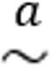$N\left(β,{\left(Z^{'}X\right)}^{-1}\left(\sum_{i=1}^{N}{e_{i}^{2}z_{i}z_{i}^{'}}\right){\left(Z'X\right)}^{-1}\right)$

Over-Identified IV/2SLS
= number of instruments L is larger than the number of endogenous variables (L>K)

2SLS
Moment conditions: $Z^{'}ϵ=Z^{'}\left(y-Xβ\right)=0$
dimension $L×1$, but we only have K unknowns not all L moments satisfied
Which ${\hat{β}}_{IV}$? Weight moments and select the $\hat{β}$ that minimized the weighted sum of the moments optimal weight: 2SLS

The Two Stages

1st Stage

1st Stage Regression
Regress the included RHS endogenous, $x_{1i}$, variables on all the instruments, $z_{i}$:
$X_{1}=Zπ+v$ $\hat{π}$ ${\hat{X}}_{1}=Z\hat{π}$ (${\hat{X}}_{1}$ is the part of $X_{1}$ that can be explained by $Z$)

Joint Significance of the Instruments
Joint significance of the instruments $Z=\left[\begin{matrix}Z_{1} & Z_{2}\end{matrix}\right]$
reduced form equation: $x_{1i}=z_{1i}^{'}π_{1}+z_{2i}^{'}π_{2}+v_{i1}$
F-statistic for the hypothesis H₀: $π_{1}=0$ ($L_{1}$ numerator degrees of freedom,
$N-K_{2}-1$ denominator degrees of freedom)
Typical rule of thumb: F-test $>10$ (or for one instrument: t-statistic $>\sqrt{10}=3.16$

2nd Stage
Regress $y$ on ${\hat{X}}_{1}$ and $X_{2}:$
$y={\hat{X}}_{1}β_{1}+X_{2}β_{2}+ϵ$
$=\hat{X}β+ϵ$ where $\hat{X}=\left[\begin{matrix}{\hat{X}}_{1} & X_{2}\end{matrix}\right]$
2SLS: Replace the problematic variables with their fitted values (with are a function of exogenous instruments)
(!Actually running the two regressions gives wrong standard errors, because Stata/R does not now that the second regression uses fitted values of the independent variables!)

2SLS using the Projection Matrix $P_{Z}$
Projection matrix: $P_{X}=X{\left(X^{'}X\right)}^{-1}X^{'}$ gives the fitted value of a regression of <anything> on X
First-stage regression of $x_{1i}$ on $z_{i}$: $X_{1}=Zπ+v$
$\hat{π}={\left(Z^{'}Z\right)}^{-1}Z^{'}X_{1}$
${\hat{X}}_{1}=Z\hat{π}=Z{\left(Z^{'}Z\right)}^{-1}Z^{'}X_{1}=P_{Z}X_{1}$ where $Z=\left[\begin{matrix}Z_{1} & X_{2}\end{matrix}\right]$ $P_{Z}X_{2}=X_{2}$
$Z_{2SLS}=P_{Z}X$ and $Z_{2SLS}^{'}=X^{'}P_{Z}$
${\hat{β}}_{2SLS}={\left(Z_{2SLS}^{'}X\right)}^{-1}Z_{2SLS}^{'}y$
$={\left(X^{'}P_{Z}X\right)}^{-1}X^{'}P_{Z}y$
$={\left(X^{'}Z{\left(Z^{'}Z\right)}^{-1 }X\right)}^{-1}X^{'}Z{\left(Z^{'}Z\right)}^{-1}Z^{'}y$

Consistency
${\hat{β}}_{2SLS}\underset{→}{p}β$
Under A3 and A4:
${\hat{β}}_{2SLS}N\left(β, σ^{2}{\left(X^{'}P_{Z}X\right)}^{-1}\right)$
$N\left(β, σ^{2}{\left(X^{'}Z{\left(Z^{'}Z\right)}^{-1}Z'X\right)}^{-1}\right)$
consistent BUT higher variance

IV
Same as just-identified case

IV Intuition
Take one of the elements of the endogenous $X_{1}$ and divide into two parts:
- a problematic part, which is correlated with $ϵ_{i}$ variation in this part induced by instruments
- a non-problematic part, which is uncorrelated with $ϵ_{i}$
rely on the non-problematic variation in $X_{1}$ to identify $β$
less precise, i.e. higher variance, because less variation in $X_{1}$

Practical Considerations

Finding instruments
Use exogenous “initial conditions”, i.e. parent’s characteristics, “innate” attributes…

IV standard errors
IV often have larger standard errors, because using instruments, we only consider the variation of $x_{i}$ caused by $z_{i}$, i.e. less variation and therefore have higher SE

Weak Instruments
= instruments with small joint significance in the first-stage regression, i.e. F-test < 10 for each instrument low correlation between instruments and included endogenous variables
Problem: they can exacerbate finite-sample bias, i.e. IV estimator biased towards the OLS estimator in small samples
Estimate the size of bias with one instrument: 1/F
with multiple instruments: minimum eigenvalue matrix
Solutions: if too many instruments, drop weak ones
if small-sample bias, use other estimator than 2SLS

Testing
only possible with valid instruments!

Testing Endogeneity (Hausman Endogeneity Test)
= test whether a regressor, $x_{1i}$, is correlated with the error term, $ϵ_{i1}$
structural equation: $y_{i}=x_{1i}β_{1}+x_{2i}^{'}β_{2}+ϵ_{i1}$
reduced form equation: $x_{1i}=z_{1i}^{'}π_{1}+x_{2i}^{'}π_{2}+v_{i1}$
the only way $x_{1i}$ can be correlated with $ϵ_{i1}$ is $v_{i1}$ (because of assumptions of instruments)
estimate $v_{i1}$ as the residual of the reduced-form and put it into the structural equation:
$y_{i}=x_{1i}^{'}β_{1}+x_{2i}^{'}β_{2}+δ{\hat{v}}_{i1}+ϵ_{i1}^{*}$
test H₀: $δ=0$ if we can reject H₀, we have endogeneity
Slides 85&86

Testing Overidentifying Restrictions (J-Test)
only if over-identified (otherwise $Z^{'}ϵ=0$ always true)
Three steps:
- Estimate the structural equation by 2SLS $e_{i1}$
- Regress $e_{i1}$ on $z_{1i}$ and $x_{2i}$ (all exogenous variables) and calculate R²
- Under H₀: Instrument validity, $NR^{2}χ_{L1-K1}^{2}$ (degrees of freedom = # “extra” instruments)

PANEL DATA!

Examples

Example 1: Correlated Unobservables
Regression of wage on education
Problem: correlated unobservable: ability
Bias: Positive (because positive correlation btw education and ability and btw ability and wage)
Instrument: parents’ education
Relevance: OK, because parents’ education likely to be correlated with education
Exogeneity: NO, parents’ education likely to be correlated with ability (e.g. more educated parents can probably help the child to develop ability)

Example 2: Measurement Error
Regression of health insurance coverage on income
Problem: attenuation bias
Instrument: high-school completion rate
Relevance: OK, because high-school completion very likely to be correlated with income
Exogeneity: NO, because ???

Example 3: Simultaneous Equations
Supply and demand of truffles
Problem: simultaneous causality
Instrument: rental price of truffle pigs (”input price” supply shifter)
Relevance: OK, because rental price of truffle pigs very likely correlated with the supply of truffles
Exogeneity: OK, because demand for truffles not correlated with rental price of truffle pigs

Tutorials

Interpretation of Coefficients

Level-level
$Y_{i}=α+β_{1}X_{1i}+β_{2}X_{2i}+…+ϵ_{i}$
$β_{1}=\frac{∂Y_{i}}{∂X_{1i}}$
marginal effect, i.e. effect of a one-unit change in $X_{1i}$ if holding all other variables constant
If $X_{1i}$ is changed by 1 unit, $Y_{i}$ changes by $β_{1}$ units (if everything else is hold constant)

Log-log
$\log{Y_{i}}=α+β_{1}\log\left(X_{1i}\right)+β_{2}X_{2i}+…+ϵ_{i}$
$d\left[log\left(Y_{i}\right)\right]=β_{1}d\left[log\left(X_{1i}\right)\right]$
$\frac{1}{Y_{i}}dY_{i}=β_{1}\frac{1}{X_{1i}}dX_{1i}$
$\frac{dY_{i}}{Y_{i}}=β_{1}\frac{dX_{1i}}{X_{1i}}$
$β_{1}=\frac{\frac{{dY}_{i}}{Y_{i}}}{\frac{dX_{1i}}{X_{1i}}}=\frac{\frac{100⋅{dY}_{i}}{Y_{i}}}{\frac{100⋅dX_{1i}}{X_{1i}}}$
partial elasticity of $Y_{1}$ with respect to $X_{1i}$
If $X_{1i}$ is changed by 1%, $Y_{i}$ changes by $β_{1}$% (if everything else is hold constant)

Log-level
$\log{Y_{i}}=α+β_{1}X_{1i}+β_{2}X_{2i}+…+ϵ_{i}$
$d\left[log\left(Y_{i}\right)\right]=β_{1}{dX}_{1i}$
$\frac{1}{Y_{i}}{dY}_{i}=β_{1}{dX}_{1i}$
$\frac{{dY}_{i}}{Y_{i}}=β_{1}{dX}_{1i}$ | $⋅100$
$100⋅\frac{{dY}_{i}}{Y_{i}}=100⋅β_{1}{dX}_{1i}$
$100⋅β_{1}=\frac{100⋅\frac{{dY}_{i}}{Y_{i}}}{{dX}_{1i}}=\frac{\%ΔY_{i}}{unitΔX_{1i}}$
If $X_{1i}$ is changed by 1 unit, $Y_{i}$ changes by $100⋅β_{1}$% (if everything else is hold constant)
This is only approximately true!
Exactly: $\%ΔY_{i}=100⋅\left(e^{β_{1}}-1\right)$

Level-log
$Y_{i}=α+β_{1}\log{X_{1i}}+β_{2}X_{2i}+…+ϵ_{i}$
${dY}_{i}=β_{1}d\left[log\left(X_{1i}\right)\right]$
${dY}_{i}=β_{1}{\frac{1}{X_{1i}}dX}_{1i}$
${dY}_{i}=β_{1}\frac{{dX}_{1i}}{X_{1i}}$
${dY}_{i}=\frac{β_{1}}{100}\frac{100⋅{dX}_{1i}}{X_{1i}}$
$\frac{β_{1}}{100}=\frac{{dY}_{i}}{\frac{100⋅{dX}_{1i}}{X_{1i}}}=\frac{unitΔY_{i}}{\%ΔX_{1i}}$
If $X_{1i}$ is changed by 1%, $Y_{i}$ changes by $\frac{β_{1}}{100}$ units (if everything else is hold constant)

